MICROCLIMATIC VARIATIONS IN A INTERMONTANE DEPRESSION IN COSTA RICA

VARIACIONES MICROCLIMATICAS EN UNA DEPRESIÓN INTERMONTANA EN COSTA RICA

Marvin E. Quesada

**RESUMEN**

Las partes altas de las montañas y las depresiones intermontanas se caracterizan por mostrar condiciones microclimáticas muy inestables comparado con otras regiones del territorio costarricense. Se investigan cuatro estaciones climáticas: tres ubicadas en las partes altas de la cordillera y una ubicada en un sector a menor altitud, todas coinciden con una depresión intermontana. Se investigó la precipitación total mensual, el promedio diario mensual, probabilidad de días lluviosos, probabilidad de días con precipitación superior a 10, 20 y 30 mm, precipitación máxima diaria mensual. Se ha encontrado que la depresión intermontana que por su condición geomorfológica permite la incursión de masas de aire cargadas de humedad durante una época del año, mientras que en otras más bien se da un efecto de subsidencia. Durante la primera máxima de precipitación en tres de las estaciones climáticas ubicadas más hacia el sector Pacífico existe más influencia de la Zona de Convergencia Intertropical (ZCIT). En tanto, a final y principio del año se producen intensas precipitaciones, producto de la incursión de la influencia de Los vientos Nortes. La precipitación mensual es mayor en los sectores de Miramar y Piedades Sur en el mes de Julio. En cambio, las estaciones de Zarcero y ReBAMB presentan una mayor precipitación diaria al estar ubicadas a mayor altitud reciben las masas cargadas de humedad, sobre todo desde la vertiente Caribe que presenta lluvias durante la mayor parte del año. Además, el sector en estudio a pesar de la presentar altitudes superiores a los 1300 m.s.n.m en su mayoría esta influenciado por la variación anual y a veces estacional del evento El ENOS.

**Palabras claves**: Precipitación, depresión intermontana, microclimas, lluvia diaria, ENOS.

**ABSTRACT**

The high parts of the mountains and intermontane depressions are characterized by very unstable with microclimatic conditions compared to other regions of Costa Rican territory. Four climatic stations are investigated: three located in the upper parts of the mountain range and one located in a lower altitude sector, all coincide with an intermontane depression. The total monthly precipitation, the monthly daily average, probability of rainy days, probability of days with precipitation greater than 10, 20 and 30 mm, maximum monthly daily precipitation was investigated. Intermontane depression has been found to allow for the incursion of moisture-laden air masses for one time of the year, while in others rather a subsidence effect occurs. During the first rush maximum at three of the climate stations located further into the Pacific sector there is more influence from the Intertropical Convergence Zone (ITCZ). Meanwhile, at the end and beginning of the year there is intense rainfall, the result of the incursion of the influence of The North Winds. Monthly precipitation is highest in the Miramar and Piedades Sur sectors in July. By contrast, the Zarcero and ReBAMB seasons have a higher daily rainfall being located at higher altitudes receive the masses laden with moisture, especially from the Caribbean side that presents rains for most of the year. In addition, the area under study despite having altitudes above 1500 m.s.n.m is mostly influenced by the annual and sometimes seasonal variation of the ENSO event.

**Keywords:** Precipitation, intermontane depression, microclimates, daily rain, ENSO event.

**INTRODUCTION**

Costa Rica's climate diversity is highly controlled by geographic factors such as latitude, altitude and ocean influence, seasonality, among others. All of them confer a great diversity of types of climates and microclimates, from the most arid (Guanacaste), to the alpine (Cerro Chirripó). In order to site another one, for instance, it is possible to find rainy, very rainy, and pluvial climates. Within each of these climates, you can find various microclimates, which exist given the topographic diversity, altitude, and factors such as leeward and windward. An example, of this microclimatic diversity is that Costa Rica, despite being a small country in its continental sector with only 50,200 km², has twelve Living Zones, according to the classification of R. L Holdridge (1982). In addition, the influence of the Intertropical Convergence Zone (ITCZ), seasonal and annual winds, as well as the North Atlantic Anticyclone (NAA), El Niño Southern Oscillation (ENSO) are the most important regulators of the country's rainfall regimes.

Climate is defined as the set of atmospheric conditions that vary according to the states and time evolutions of a given region (IHMEA. 2016). Some of the atmospheric variables that describe a territory's climate are temperature and precipitation. However, it is necessary to identify other components of the climate system in order to characterize it (Alves & Marengo, 2010). Rainfall is associated with different climatic elements such as air temperature, humidity, wind speed and direction, atmospheric pressure, evaporation, heatstroke, and prevailing weather (e.g., fog, hail and thunder) (OMM, 2011).

Over time, climate variations have originated that are observed by the measurement and monitoring of weather variables and phenomena comprising a climate (Pabón et al., 2000). In contrast, atmospheric weather is the weather conditions that occur in a place determined by a few hours, days, weeks. These can occur through extreme humidity conditions that lead to flooding or periods of one or two weeks raining or storms. In the meantime, conditions of atmospheric stability such as droughts, dry month periods or extension of the dry season or overtaking of the dry period may occur.

Precipitation is an important variable in understanding the impacts of climate change. Studies indicate that precipitation patterns in Central America, including Costa Rica will likely change, affecting water resources, cattle raising, the lives of millions of people ([Roy](https://rmets.onlinelibrary.wiley.com/action/doSearch?ContribAuthorStored=Sen+Roy%2C+Shouraseni) and Balling, 2004; IPCC, 2014). Changes in the intensity of extreme climate events have drastic effects on the environment and population. Therefore, it is imperative to analyze extreme events, particularly monthly and daily rainfall. The detection and attribution of changes in rainfall extremes at the daily time scale (Sohrabi et al, 2013) could show how often the weather changes in an intertropical country like Costa Rica.

The success of agriculture, cattle raising, livestock and some other human endeavors depends greatly on the vagaries of daily rainfall conditions. In the absence of artificial impoundments or access to wells, a sequence of dry days at a particularly crucial time in the growing season, livestock, and forest grow can have devastating consequences. Likewise, excessive rains can cause soil erosion and the loss of seeds and young plants, while a sequence of wet days at the time of harvest can damage crops and prevent removal (Peterson, et al., 2002).

In seeking modern parallels to hypothesized future conditions, the National Institute of Meteorology (IMN) of Costa Rica, concluded that the climate conditions for 2080 would be very similar to those currently experienced during a strong El Niño episode. The El Niño–Southern Oscillation (ENSO) phenomenon is the principal cause of global interannual variability in climate. Both the warm (El Niño) and cold (La Niña) phases of ENSO exhibit considerable variability in strength and regional influence from event to event. The global impacts of ENSO extend to ecosystems, agriculture, and water resources, in both continental and marine habitats. For example, the strong El Niño of 2015 produced extensive droughts on the Pacific slope of Costa Rica, which devastated harvests and cattle. Meanwhile, extensive floods inundated the Caribbean cost. The phases of ENSO affect security, economies, and social stability (Glantz, 2001 McPhaden, 2006; Iizumi et al., 2014; Barnard et al., 2015) underscoring the present necessity to understand its impacts to better inform management of resources.

According to Santoso, et al, 2017 extreme cold phase (La Niña) events tend to be less studied, but their impacts can be equally dramatic. For instance, the 1998 event was associated with catastrophic flooding events that claimed thousands of lives in Bangladesh, Venezuela, and China (Ninno and Dorosh, 2001; Jonkman, 2005; Takahashi and Dewitte, 2016). Particularly worrisome is the fact that opposing phases often follow each other closely, compounding their individual impacts. Such swings in extreme phases have been projected to occur more frequently under greenhouse warming (Cai et al., 2014)

**STUDY AREA**

The mountain depression between the Tilarán mountain range section and the Central in the Northwest of Costa Rica. This territory is very representative of some gap’s existent between mountain range sections, which supports extensive agricultural activity, livestock, and forest (figure 1). This gap region possesses a tropical rainforest, or equatorial climate. Some of this area receiving a little bit precipitation during some months and the rest are very wet throughout the entire year (figure 1), but particularly so when the northeast trade winds (*Alisios*) and the Los Nortes blow most strongly (May-August and November-January) (Poveda et al., 2014). Embedded within the trade winds a fast-flowing region of air at about, the Caribbean Low-Level Jet (CLLJ) (Wang, 2007; Hidalgo et al., 2015). During the boreal winter, incursions of cold air (*Los* *Nortes*) from North America are associated precipitation and surface convergence (Shultz et al., 1998). Both the *Alisios* and *Los* *Nortes* fluctuate to vary degree with the phases of ENSO (Waylen et al., 1996, Poveda et al., 2006) and it is therefore reasonable to hypothesize that this will be reflected in the daily rainfall characteristics, which have great local importance for agriculture and water resources planning.

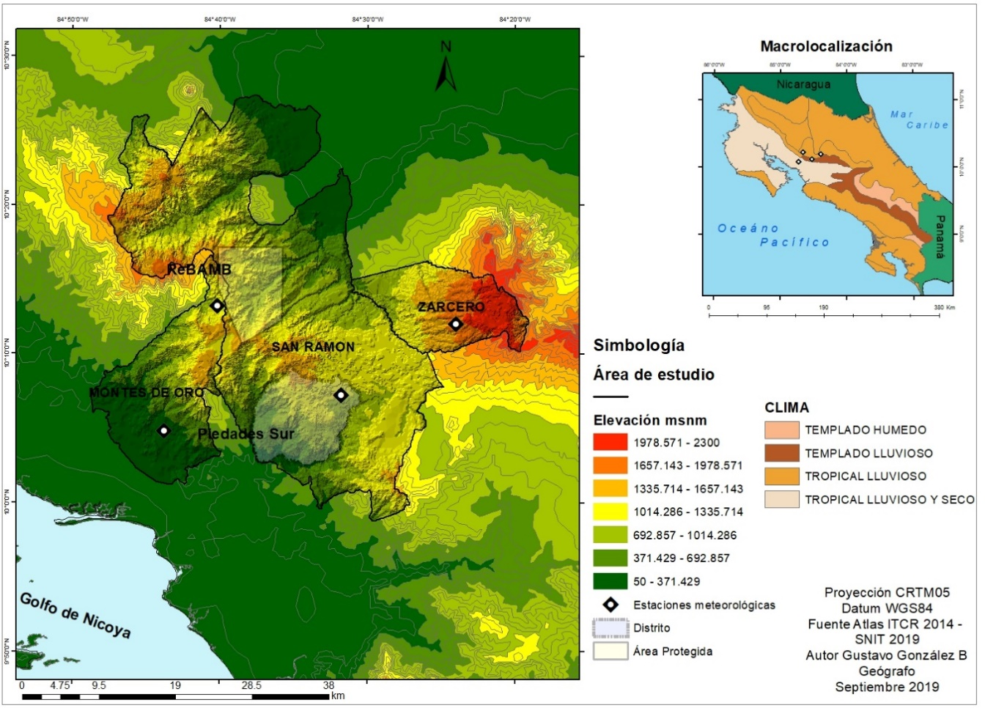

Fig. 1. Mountain depression between the Tilarán mountain range section and the Central. Source: Own elaboration based on data of the IMN of Costa Rica, 2020.

**DATA AND METHODS:**

IMN provided digitized daily records over the period 1999-2019 inclusive. The number of months of complete record range from 210 to 240 for thirty years. From each complete month of record, the following variables are extracted:

Monthy Precipitation Total

$$\sum_{i=1}^{n}{}P_{i}$$

Where n = number of days in the month

Pi = daily rainfall total

Mean Daily Precipitation

$$\frac{1}{m}\sum_{i=1}^{n}{}P_{i}$$

Where m = number of days in month with measurable precipitation

Probability of Wet Day

$$\frac{m}{n}$$

Probability of Daily Total Greater Than 10 mm

$$\frac{m_{10}}{n}$$

Where m10 =number of days in month with measurable precipitation greater than 10 mm

Probability of Daily Total Greater Than 20 mm

$$\frac{m_{20}}{n}$$

Where m20 =number of days in month with measurable precipitation greater than 20 mm

Probability of Daily Total Greater Than 30 mm

$$\frac{m_{30}}{n}$$

Where m30 =number of days in month with measurable precipitation greater than 30 mm

Monthly Maximum Daily Precipitation

$(P_{i}$)

The second variable indicates the frequency with which the daily precipitation process occurs, and the third to sixth variables provide some indication of the magnitude of the process. The monthly total is a function of both the changing frequency and magnitude of events. Although monthly totals are more commonly used in the analysis of climatic data, partly because they are more widely available, changes in the frequency and magnitude of the process.

**RESULTS**

The region under study has a unique particularity that it is typical of mountain depressions, according to its morphology, particular climatic characteristics. Jaramillo (2005) points out how the effect of a mountain range on moving air depends, first, on the characteristics of the orographic barrier such as height, width, length, and distance between successive barriers, and second, on the characteristics of wind direction, vertical profile, and atmosphere stability. On the other hand, the rain increases with the altitude to a maximum level that varies according to the slope, but usually the maximum rain occurs between 1300 and 1700 m.o.s.l, from this level the rain begins to decrease with the height (Jaramillo, 2005).

In the mountain depression under study, the presence of ICTZ must appear, during two bimonthly periods. This annual distribution of bimodal rain, that is, with two maximum rainfall peaks in the year, produces mainly on the Pacific slope torrential rains. In this way, this bimodal regimen is presented in the months of May-June and September-October and two other periods without rain in the months of December-March and July-August. On the Caribbean and North subvert, very different conditions normally occur, there are unimodal conditions, except in those cases of stations very close to the continental divide (Jaramillo, 2005).

However, the mountain depression is also influenced by trade winds coming from the Northeast and at the end and beginning of the year (December, January, and February), The Northern (*Los Nortes*) are stronger, causing floods in certain areas like sixaola, Matina, Llanuras Tortuguero, Limón, Sarapiquí and constant rains in the high mountains. These winds are laden with moisture and usually produce precipitation for most of the year. These tend to increase when you have an El Niño period and vice versa when it is a La Niña period.

In order to analyze the rain in the area, it was considering four meteorological stations located in the area (Zarcero, Reserva (ReBAMB), Montes de Oro and Piedades Sur), which has at least thirty years of data. It is necessary to take into consideration the faint grey/yellow line indicates the Neutral phase of ENSO. The red circles are El Niño (Warm phase) ENSO and the blue diamonds, La Niña (Cold phase). In general, there are about 40 observations from Neutral years, about 18 for Warm years and 16 for Cold years. The numbers vary a bit from month to month. December is at the top of the circle and June at the bottom.

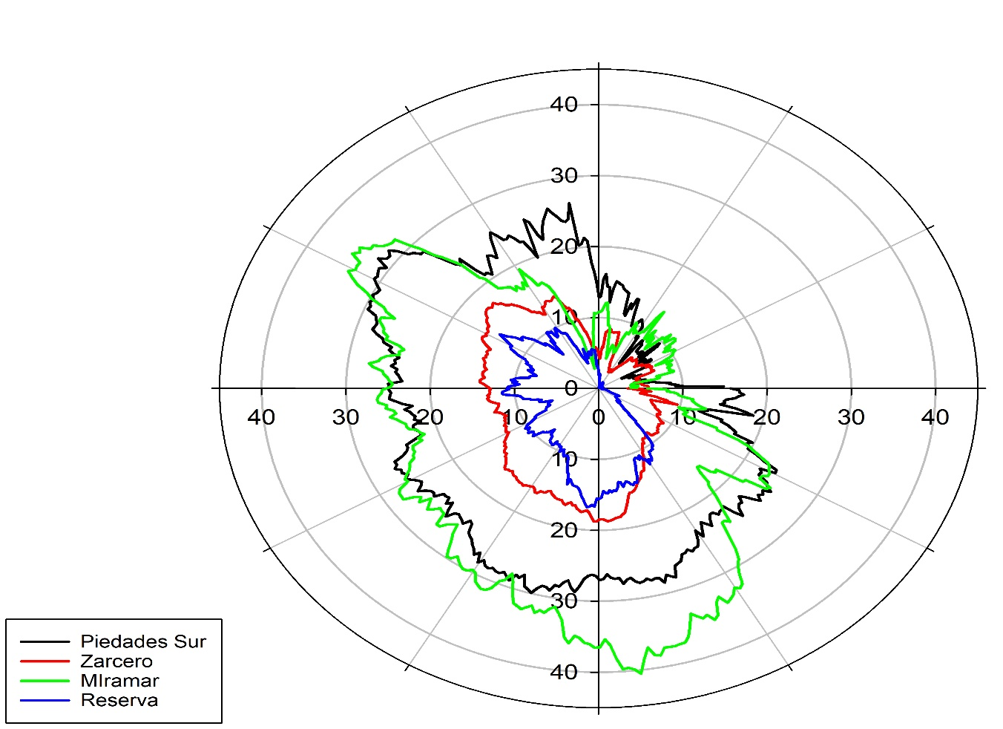

Figure 2. Mean monthly rainfall totals for Zarcero, ReBAMB, Miramar and Piedades Sur. Source: Own elaboration based on IMN data, Costa Rica, 2020.

These are the mean monthly precipitation totals (mm) for the four stations under different months. During December, January, February and March look to be a small amount of precipitation. From April the four stations show an increase in precipitation until, practically mid-December. However, there are certain months that show a greater amount of precipitation, such as the months of May, June, July, August, September, October and November.

On the other hand, some meteorological stations show a greater monthly amount of precipitation, such as the climatic station of Miramar and Piedades Sur throughout the year. This is due to the presence of ITCZ and the incursion of air masses from the Caribbean sector and which manage to venture through the depression of Bajo Tapezco, which is the lowest altitude sector of the mountain depression that exists between the Tilarán mountain range sections and the Central.

However, ReBAMB and Zarcero meteorological stations that are located on the Caribbean side have less amount of monthly precipitation, being the Reserve, the one that showed the least amount of precipitation. In both meteorological stations there are topographic barriers that prevent the constant incursion of moisture-laden air masses.

Most of the Pacific side show a small decrease in precipitation during July and August, which is called Veranillos, that happens because the ITCZ goes Northward during those months. However, in this case, such a condition it is not shown, the altitude of Miramar and Piedades Sur meteorological stations. The reserve's plot is more like Zarcero, than the other two seasons are, given that both are more towards the Caribbean sector, despite its location very close to the continental divide. Meanwhile, the red and blue lines belong to the climatological stations of Piedades Sur and Miramar that are located on the Pacific side, being the rainy conditions very different.

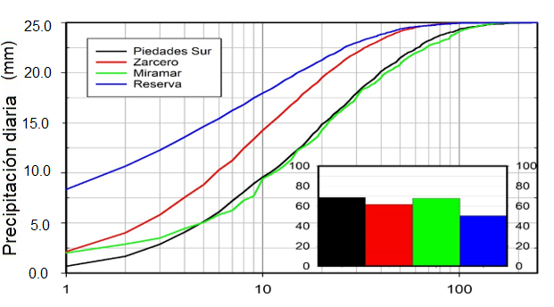

Fig. 3. Daily precipitation in the four seasons under study. Source: Own elaboration based on records of IMN stations, 2020.

The following figures show the simultaneous behavior of daily precipitation in all four stations. The abscissa axis, in logarithmic scale, is the total daily precipitation (mm). The vertical axis is the accumulated frequency at which, the total is displayed or is the value observed in the four stations. You can see the similar ones between Piedades Sur and Miramar. Precipitation falling in the ReBAMB is different from the others, but with a greater affinity with Zarcero.

Below are four diagrams that summarize for each season in each month, the following aspects: a) The relative frequency of dry days b) The relative frequencies of precipitation totals, which were divided into category ranges of 5 mm, up to 30 mm.

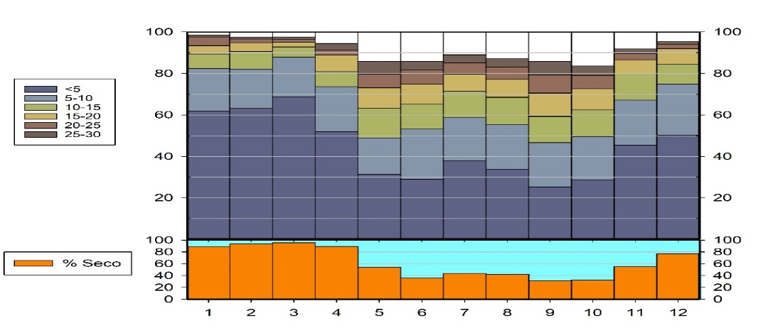Fig.4. Monthly distribution as a percentage of daily rainfall in Zarcero. Source: Own creation based on data of the IMN, 2020

The figure. 4 shows the frequency of the year-round rainfall process in Zarcero station and the magnitude of the rain when they fall. The ReBAMB and Zarcero manifest a high frequency and low magnitude. While Piedades Sur and Miramar, rather have low frequency and high magnitude.

Figure 5 shows the percentage of all daily precipitation observations, 50% of the days in the REBAMB were dry. The orange diagram at the bottom describes the percentage of days in each month when the largest top diagram is dry is a "stacked bar chart" with the percentages of rainy days that the total fell into several categories. Shown in the legend on the left, the white area represents daily rainfall values greater than 30 mm. The x-axis is the month of the year. The lower (orange) is the percentage of days per month that are dry, and the top charts are the cumulative percentages of daily precipitation totals.

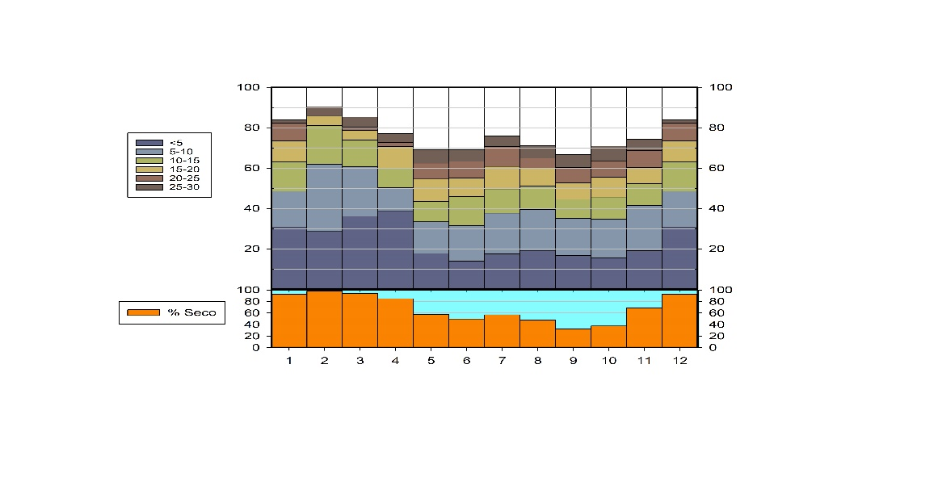

Fig. 5. Monthly distribution as a percentage of daily precipitation in REBAMB. Source: Own creation based on data of the IMN, 2020.

Again, the REBAMB has a more similar behavior to Zarcero's. It shows a higher frequency of rainy days than the case of Piedades Sur and Miramar and a higher percentage of totals with low precipitation. This could be due to the altitude at which the ReBAMB weather station is located.

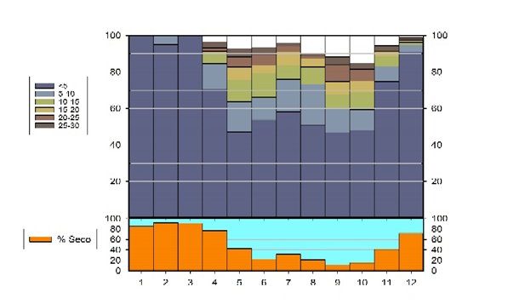

Fig. 6. Monthly distribution as a percentage of daily precipitation in Piedades Sur. Source: Own creation based on data of the IMN, 2020.

The figure 6 shows that in the station of Piedades Sur there are more dry days, from May to November. Meanwhile, during these months’ present increases in precipitation greater than 25 and 30 mm daily.

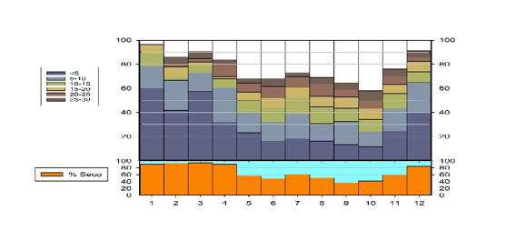

Fig 7. Monthly distribution as a percentage of daily precipitation in Miramar. Source: Own creation based on data of the IMN, 2020.

The 7 shows that in the station of Miramar presents also some more dry days, from May to November. Meanwhile, during these months there are increases in precipitation greater than 25 and 30 mm daily.

In addition, it can be observed that stations with the least percentage of dry months are Piedades Sur and Miramar. However, when looking at the higher percentages of precipitation it is noted that Piedades Sur receives higher levels of precipitation. This is possibly due to its location in the direction of the mountain depression of the lower Tapezco, where the air masses go through and that reaches and causes with greater magnitudes of precipitation.

**DISCUSSION AND CONCLUSIONS**

The climatic spatial pattern shown by the four stations under study varies by topographical irregularity. However, there is some similarity as already mentioned between the stations located in the vicinity of the continental divide such as Zarcero and the ReBAMB. On the other hand, there are the stations of Piedades Sur and Miramar with certain similarities. To analyze the daily extremes in precipitation two seasons were chosen, Zarcero with typical rains of the highest altitude floor and Piedades Sur located at a lower altitude and influenced by air masses entering the Caribbean sector. Approximately 68% were dry in Piedades and Miramar and Zarcero (62%).

Central America is subject to considerable year-on-year rainfall variability. There are certain intensifications on variability in precipitation. These include anomalies in sea surface temperatures (TSMs). In both oceans the Equatorial Pacific and North Atlantic (Hastenrath, 1998; Enfield and Alfaro, 1999; Enfield et al, 2001; Taylor et al., 2012).

The correlation between precipitation in Central America and North Atlantic surface temperature (TSAN) in each ocean basin is of opposite sign, with positive TSAN in the Pacific (Atlantic) basins associated with precipitation (increase) decrease in the region (Enfield and Alfaro, 1999). In this way, the oceans behave in different ways, in terms of the surface temperature of the oceans. An example of this is shown in the following figure showing that when surface ocean temperatures in the Pacific Ocean are low in the Atlantic, they remain high. This leads to territories such as Costa Rica having spatial variations in precipitation for seasonal, monthly, and even daily periods.

In addition, the effect of tropical eastern Atlantic and Pacific oceans individually, the interaction of TSAN in these basins has also been shown to affect rainfall variability in the region (Enfield and Alfaro, 1999; Giannini et al., 2000; Spence et al., 2004). A strong response is given in the precipitation over Costa Rica in the final rainy season through early dry season (August to January) to concurrent ATSM in the Atlantic and Pacific Oceans (Spence et al., 2004). Tropical Eastern and Pacific Tropical Atlantic North have met to counter each other their SSTAs are of the same sign and reinforce each other when they are of opposite sign (Enfield and Alfaro, 1999; Spence et al., 2004).

**Thanks**

The Vicerrectoría de Investigación is recognized for its partial support in funding this research and the Coordinación de Investigación of the Sede de Occidente for allowing me to carry out this research. Both belong to the University of Costa Rica.

**REFERENCES**

Alves, L.M.; Marengo, J. 2010. Assessment of regional seasonal predictability using the PRECIS regional climate modeling system over South America. Theoretical and Applied Climatology, 100 (3-4), 337-350.

Barnard PL, Short AD, Harley MD, Splinter KD, Vitousek S, Turner IL, Allan J, Banno M, Bryan KR, Doria A and Hansen JE (2015): Coastal vulnerability across the Pacific dominated by El Nino/Southern Oscillation. Nature Geoscience, 8:801-807.

Cai, W., Borlace, S., Lengaigne, M., Van Rensch, P., Collins, M., Vecchi, G., Timmermann, A., Santoso, A., McPhaden, M.J., Wu, L. and England, M.H., 2014. Increasing frequency of extreme El Niño events due to greenhouse warming. *Nature climate change*, *4*(2), pp.111-116. JANUARY

Carrera-Villacrés, D.V.; Guevara-García, P.V.; Tamayo-Bacacela, L.C.; Balarezo-Aguilar, A.L.; Narváez-Rivera, C.A; Morocho-López, D.R. 2016. Relleno de series anuales de datos meteorológicos mediante métodos estadísticos en la zona costera e interandina del Ecuador, y cálculo de la precipitación media. *Idesia* (Arica), 34 (3): 81-90.

Enfield, D.B., Alfaro, E.J., 1999. The dependence of Caribbean rainfall on the interaction of the tropical Atlantic and Pacific oceans. J. Climate 12, 2093 – 2103

Enfield, D., Mesta-Nunez, A., Markgraf, V. (Eds.), 2001. Interhemispheric Climatic Linkages. Academic Press, San Diego. 454 pp.

IHMEA. 2016. Boletín Informativo sobre el monitoreo de los fenómenos de variabilidad climática "El Niño y la Niña ". Instituto de Hidrología, Meteorología y Estudios Ambientales. Bogotá, D. C., Colombia, 6 p.

IPCC 2014 Summary for policymakers In: Climate Change 2014: Impacts, Adaptation, and Vulnerability. Part A: Global and Sectoral Aspects. Contribution of Working Group II to the Fifth Assessment Report of the Intergovernmental Panel on Climate Change ed. CB Field et al. (Cambridge) (Cambridge University Press) (Cambridge, United Kingdom and New York, NY, USA) pp 1–32.

Glantz, M.H., 2001. Current of Change: Impacts of El Nino and La Nina on Climate and Society, 760 pp.Cambridge University Press, Cambridge, U.K.

Guillén-Oviedo, H.S., Cid-Serrano, L.R. and Alfaro-Martínez, E.J., 2020. Comparación de parámetros de valor extremo de la distribución generalizada asociada a eventos de precipitación extrema en América Central. *Uniciencia*, Vol. 34, N° 1, pp. 111-128. Enero-Junio.

Hastenrath, S., 1998. Contribution to the circulation climatology of the eastern equatorial Pacific: Lower atmospheric jets. J. Geophys. Res. 103 (D16), 19443 – 19451.

Hidalgo, H.G., Durán‐Quesada, A.M., Amador, J.A. and Alfaro, E.J., 2015. The Caribbean low‐level jet, the inter‐tropical convergence zone and precipitation patterns in the intra‐Americas sea: A proposed dynamical mechanism. *Geografiska Annaler: Series A, Physical Geography*, *97*(1), pp.41-59.

Holdridge R. 1982. Ecología basada en zonas de vida. Instituto Interamericano de Cooperación para la Agricultura. San José, Costa Rica.

Jaramillo. (2005). Clima Andino y café colombiano. Cenicafe. P.p. 196.

Jonkman, S.N., 2005. Global perspectives on loss of human life caused by floods. *Natural hazards*, *34*(2), pp.151-175.

Iizumi, T., Luo, J.J., Challinor, A.J., Sakurai, G., Yokozawa, M., Sakuma, H., Brown, M.E. and Yamagata, T., 2014. Impacts of El Niño Southern Oscillation on the global yields of major crops. *Nature communications*, *5*(1), pp.1-7.

Ninno CD and Dorosh PA (2001): Averting a food crisis: private imports and public targeted distribution in Bangladesh after the 1998 flood. Agricultural Economics, 25:337-346.

Muñoz, E., Busalacchi, A.J., Nigam, S. and Ruiz-Barradas, A., 2008. Winter and summer structure of the Caribbean low-level jet. *Journal of Climate*, *21*(6), pp.1260-1276.

McPhaden. M (2006). Genesis and Evolution of the 1997-98 El Niño. *Science, 314*(5806), 1740–1745.

OMM. Guía de prácticas climatológicas. Organización Meteorológica Mundial. Ginebra, Suiza, 128 p.

Pabón, J.; Zea, J.; León, G.; González, O.; Montealegre, J. and Hurtado, G. 2000. La atmósfera, el tiempo y el clima. En: Leyva, P., Ed., El medio ambiente en Colombia, Bogotá. IDEAM. Colombia, Bogotá, pp. 35-91.

Peterson TC, Taylor MA, Demeritte R, Duncombe DL, Burton S, Thompson F, Porter A, Mercedes M, Villegas E, Semexant Fils R and Klein Tank A (2002): Recent changes in climate extremes in the Caribbean region. Journal of Geophysical Research: Atmospheres, 107(D21), 16 pp.

Poveda G, Waylen PR and Pulwarty RS (2006): Annual and inter-annual variability of the present climate in northern South America and southern Mesoamerica. Palaeogeography, Palaeoclimatology, Palaeoecology, 234:3-27

Poveda G, Jaramillo L and Vallejo LF (2014): Seasonal precipitation patterns along pathways of South American low-level jets and aerial rivers. Water Resources Research, 50:98-118.

PNUD (Programa de la Naciones Unidas para el Desarrollo Colombia-PNUD, Unidad Nacional para la Gestión del Riesgo). 2012. Proyecto Gestión Integral del Riesgo y Adaptación al Cambio Climático Caribe PNUD-UNGRD, "Plan Departamental de Gestión del Riesgo Atlántico". Panamericana. Bogotá, Colombia, 97 p.

Quesada-Hernández, L.E., Hidalgo, H.G. and Alfaro, E.J., 2020. Asociación entre algunos índices de sequía e impactos socio-productivos en el Pacífico Norte de Costa Rica. *Revista de Ciencias Ambientales*, *54* (1), pp.16-32.

Rodríguez, R.; Benito, Á. and Portela, A. 2004. Meteorología y Clima. En: Meteorología y Clima. Fundación Española para la Ciencia y la Tecnología FECYT(Ed.). Madrid, España, pp. 3-88.

Sánchez-Gutiérrez, R., Mena-Rivera, L., Sánchez-Murillo, R., Fonseca-Sánchez, A. and Madrigal-Solís, H., 2020. Hydrogeochemical baseline in a human-altered landscape of the central Pacific coast of Costa Rica. *Environmental Geochemistry and Health*, pp.1-17.

Santoso A, McPhaden MJ and Cai W (2017): The defining characteristics of ENSO extremes and the strong 2015/2016 El Niño. Reviews of Geophysics, 55:1079-1129.

Roy, S. and Balling Jr, R.C., 2004. Trends in extreme daily precipitation indices in India. *International Journal of Climatology: A Journal of the Royal Meteorological Society*, *24*(4), pp.457-466.

Sohrabi, M.M., Ryu, J.H. and Alijani, B., 2013. Spatial and temporal analysis of climatic extremes in the mountainous regions of Iran. *International Journal of Climate Change: Impacts & Responses*, *4*(4).

Schultz, D.M., Bracken, W.E. and Bosart, L.F., 1998. Planetary-and synoptic-scale signatures associated with Central American cold surges. *Monthly Weather Review*, *126*(1), pp.5-27.

Takahashi, K. and Dewitte, B., 2016. Strong and moderate nonlinear El Niño regimes. *Climate dynamics*, *46*(5-6), pp.1627-1645.

Taylor, K. E., Stouffer, R. J., & Meehl, G. A. (2012). An overview of CMIP5 and the experiment design. Bulletin of the American Meteorological Society, 93(4), 485–498. https://doi.org/10.1175/BAMS-D-11-00094.1

Wang C (2007). Variability of the Caribbean low-level jet and its relations to climate. Climate Dynamics, 29:411-422.

Waylen, P.R., Caviedes, C.N. and Quesada, M.E., 1996. Interannual variability of monthly precipitation in Costa Rica. *Journal of Climate*, *9* (10), pp.2606-2613.