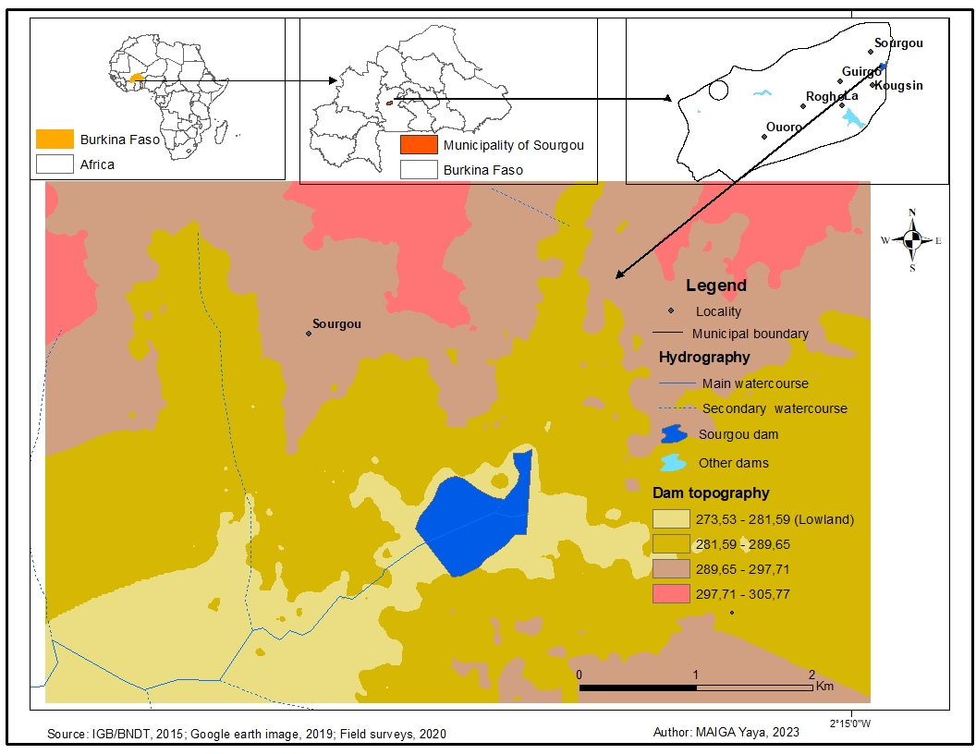

Fig.1. Geographical location of research área.

**Fig. 2.** Economic activities in the dry season in Sourgou, field surveys, 2020.

Fig.3. Size inequality of market garden plots in the Sourgou lowlands, field surveys, 2020.

1: Farmers from landowner families; 2: Farmers from group leaders' families; 3: Simple farmers; 4: Farmers from farm managers' families.

Fig. 4. Plot size by gender, family origin and farm type, field surveys, 2020.

Fig.5. Distribution of market garden plot management formalities according to gender and type of farming in the Sourgou-center lowland, field surveys, 2020.

Fig. 6. Clauses governing seizure of a plot of land, by type of farm, field surveys, 2020.

Fig.7. The conditions for withdrawing from a plot according to the producer's family origin, field surveys, 2020.