THE RHETORIC OF EMOTIONS AND FOOD CONSUMPTION IN DESPERATE HOUSEWIVES
Nieves Alberola Crespo
Universitat Jaume I de Castelló

Abstract: In Toward a Psychosociology of Contemporary Food Consumption, Roland Barthes defines food as «a system of communication, a body of images, a protocol of usages, situations and behaviour». Taking into account that American society has accepted as its own a variety of dishes that reflect a host of cultural phenomena, the aim of the present paper is to examine the rhetoric of emotions and food consumption in Desperate Housewives, a fictional universe that could be defined as a post-feminist locus amoenus in which appearance is everything and nothing is what it seems, a drama series in which emotions, behaviours and beliefs are inextricably tied to the production, distribution, and intake of food.
Keywords: Desperate Housewives, emotions, feminism, food studies, diversity.
Resumen: En Toward a Psychosociology of Contemporary Food Consumption, Roland Barthes define la comida como «un sistema de comunicación, un cuerpo de imágenes, un protocolo de prácticas, situaciones y comportamientos». Tomando como punto de partida el hecho de que la sociedad estadounidense ha aceptado como propios una gran variedad de comidas que reflejan diferentes fenómenos culturales, el presente artículo examina la retórica de las emociones y el consumo de comida en Mujeres desesperadas, un universo ficticio que podría definirse como un locus amoenus postmoderno en el que las apariencias lo son todo, en el que nada es lo que parece; una serie televisiva en la que las creencias, los comportamientos y las emociones están sujetos a la producción, distribución e ingesta de alimentos.
Palabras clave: Mujeres desesperadas, emociones, feminismo, comida, diversidad.

1. Introduction
Surnames, just like culinary preferences or habits, can reveal aspects of the cultural identities of the inhabitants of a city. In the popular television series Desperate Housewives, and more specifically in the fictional neighbourhood of Wisteria Lane (Fairview, The Eagle State), a picture-postcard neighbourhood, healthy and impeccably pleasant, several families coexist, among which the Mayers, the Van de Kamps, the Solíses and the Scavos stand out. These names can give us clues about the origin of their ancestors, as well as the varied patchwork of nationalities that make up the American identity. Dutch, English, French, Irish, Germans, and later Mexicans, Italians, and Asians, pursuing the American dream, would settle down in North America, carrying with them a formidable cultural legacy. A fundamental part of that legacy would be their rich culinary traditions.
Desperate Housewives has captured the attention of critics and the public –not just Americans– who have voiced disparate, sometimes even ambivalent, reactions to it. On the one hand, we find, for example, Samuel A. Chambers (2006: 41) who states that «Desperate Housewives motivates a significantly cultural politics, subversive in heteronormativity» (2006: 73) or Rosalind Coward who considers the series «progressive, empathetic to the dilemmas and difficulties of contemporary women» (2006: 41). But this television product also has its detractors, including New York Times journalist Alexandra Stanley and Australian feminist Germaine Greer. Alexandra Stanley in her article Political correctness has left the building (2004) says that the series is «entertaining but it turns the clock back to pre-Betty Friedan America»; she defines the four protagonists of the series as «non-feminist archetypes» and ends her article by stating that «Female empowerment is passé […] Now everybody hates women». For her part, the author of The Female Eunuch (1970), Germaine Greer, wrote in 2005 for the British newspaper The Guardian:
[…] It is neither feminist, nor pro-feminist, nor proto-feminist, nor post-feminist. Feminism has [as] little to do with Desperate Housewives […]. Indeed, it is difficult to imagine […] what outright misogynists would have done differently.
Those hard-working women who consider themselves feminists or sympathizers of movements that promote and fight for equal rights at work, do they cease to be so, if, in addition to developing their professional side, they take care of their families? Or if given the possibility of choosing between work and family, because they belong to an upper middle class in society, they opt to take care of their children, husband, and homes? And what if, due to work-related stress and the fact of hitting the glass ceiling, they have no incentive to develop themselves professionally and be happy at work and decide to return to the domestic sphere?
The debate is open and that is the reason why I consider it interesting to list some of the reasons why the series has a wide and heterogeneous audience: it is filled with secrets and mysteries that keep you intrigued; it is well written and the dialogues rely on witty humour; there is a fantastic mix of drama and comedy that matches well with the depth and complexity of the characters; it has an excellent cast of actors with a good track record; additionally, both the women and the men are good-looking and highlighted by a location of beautiful, freshly painted houses; and both the wardrobe and every little detail in the interior decoration received meticulous attention. Despite presenting an idyllic or romantic image of the suburbs, we must not forget Bree Van de Kamp’s words that you never know what happens within the walls and you must be very clear about whether or not you want to know your neighbours’ secrets.
In an interview included in the bonus content of the first season DVD, the series creator and showrunner Marc Cherry acknowledges that there could be three reasons for the success of Desperate Housewives: first, «the title is catchy» and «it promises something fun»; second, there is a «mixture of genres (comedy, drama and mystery) that other series like Dallas or Dynasty lack»; and thirdly, the series carries a message: «although some women can now choose to be wives and mothers, some are ‘not happy’ after achieving it and this indicates that ‘something is not working’». According to Cherry:
I think of our country, a country we aspire to be this idyllic place. I mean, it is really the best of what our forefathers wanted. You know a place where you can grow in communities and raise your kids, and everyone can be nice to each other. That’s the dream. The reality is there is a lot of dark stuff going on, you know, «who knows what lies in the hearts of men» kind of thing… this juxtaposition makes for the central truth of the show. (DH1: A Stroll Down Wisteria Lane)
The source of inspiration that drove him to dedicate himself to this new project is well known by critics and journalists: the shocking case of Andrea Yates, a Texan mother of five, found guilty of ending their lives by drowning them in a bathtub. In the summer of 2002, Marc Cherry was with his mother, Martha, when the news report aired. Despite not being able to understand how a mother could be so desperate as to end the lives of her children, what really shocked him was the reaction of his mother who exclaimed: «I’ve already been through that!». Amazed by Martha’s sudden and unexpected confession, he told the interviewer that he had always considered her the ideal, perfect wife and mother:
That’s what she wanted and that was her life. And it was shocking to find out that she indeed had moments of great desperation when my sisters and I were little, and my dad was off getting a master’s degree in Oklahoma, and she was starting to lose it. She started telling me these stories. And I realized if my mother had moments like this, every woman who is in this suburban jungle has. And that’s where I got the idea of writing about four housewives (in McCabe & Akass, 2006: 3).
How is it possible that a perfectly healthy and rational woman could lead the life she desired, be a wife and a mother… and yet, still have moments of madness? Cherry assumes that what was true once, is once again true, with a 21st century post-feminism twist: «women can decide for family over work but must accept responsibility for the outcome […]». And he dares to imagine what haunts the minds of his characters: «I’ve chosen it, I’m in control. Oh, I can’t blame anyone for my own unhappiness, what do I do?» (in Akass, 2006: 51-52). His words bring us back to the question: can modern 21st century women really choose what they want? Nowadays, there are still women who cannot choose between staying home or going to work but must do both to support their family.
In accordance with the marketing money spent, ABC television network was breathing life into the show’s success potential. Since its premiere in October 2004, the series has been rewarded with a myriad of awards (Emmy, Golden Globes, and Screen Actors Guild). There are many celebrities from the most diverse spheres that publicly declare themselves staunch followers of the lives of Lynette Scavo (Felicity Huffman), Bree Van de Kamp (Marcia Cross), Gabrielle Solís (Eva Longoria) and Susan Mayer (Teri Hatcher). Their fears and frustrations, the ups and downs they face, are narrated with a voice over by their late friend and neighbour, Mary Alice (Brenda Strong). Oprah Winfrey, for example, gave it more visibility by dedicating a couple of episodes of The Oprah Winfrey Show to the series. She enjoyed it very much when she recorded a short about the mysteries of the inhabitants of Wisteria Lane in the role of Karen Stouffer – information that can be found in the bonus content of the first season. For her part, Laura Bush, in a tragicomic speech during a dinner with members of the White House Correspondents Association on April 30, 2005, which was soon published in the newspapers, made a surprising reference to DH:
I am married to the President of the United States and here’s our typical evening: Nine o’clock, Mr. Excitement here is sound asleep, and I am watching Desperate Housewives with Lynne Cheney. Ladies and gentlemen, I am a desperate housewife, I mean if those women on that show think are desperate, they ought to be with George (Lavery, 2006: 18).
Desperate Housewives quickly became a cultural phenomenon; even a cookbook was published: The Desperate Housewives Cookbook. Juicy Dishes and Saucy Bits (2006), which includes 125 recipes from Christopher Styler and texts by Scott S. Tobis to satisfy all types of palates, which just underlines the importance of food in that television series. In Toward a Psychosociology of Contemporary Food Consumption, Roland Barthes defines food as «a system of communication, a body of images, a protocol of usages, situations and behaviour» (2008: 29). Hereafter, we are going to explore how emotions, behaviours and beliefs are inextricably tied to the production, distribution, and consumption of food. Our attention will be focused mainly on a core character’s culinary universe in which appearance is everything, and nothing is what it seems.

2. Who is afraid of a household Goddess in a world of appearances?
When the TV series first aired, it was not uncommon for faithful followers of the show to gather and share intimate details; one of them (who had chosen to leave her job to take care of her children, the house, the husband or some other relative) openly confessed to her friends: «Today, I had a Lynette moment»; that is, her children of three, five and six years had been overflowing with energy since seven in the morning –they could not stay still for a minute. This caring and loving housewife had not had a single moment of respite. She was exhausted, on the verge of a nervous breakdown. She had experienced an intense and terrible frustration. For a few moments she had even thought about running away, about abandoning her children; and she couldn’t help but wonder: «Why can’t I be more like Bree?»
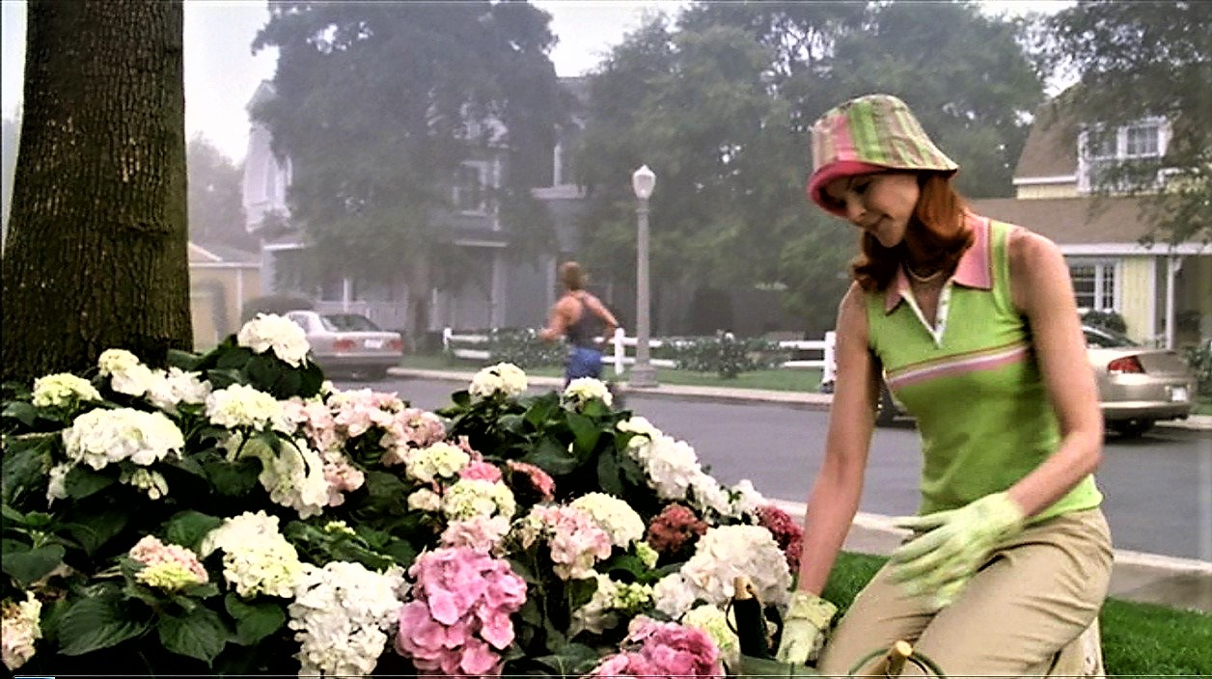
Fig. 1. Bree doing her own gardening (DH1).
The answer to this question is simple and at the same time very complex. Bree Van de Kamp (Marcia Cross) is always «perfect», «too perfect» maybe to be credible or realistic. She acts like an automaton, a mannequin, a beautiful and smiling robot straight from the novel The Stepford Wives (1970), by American writer Ira Levin. Her skills are known to everyone on Wisteria Lane: she is famous «for her cooking. And for making her own clothes. And for doing her own gardening [fig. 1]. And for re-upholstering her own furniture» (DH1: 1). She does not question her calling, her decision to live that ideal of a perfect housewife, and for this reason it can be said that she embodies the Donna Reed of the 1950s or that she is the clone of June Cleaver (Barbara Billingsley) from the Leave it to Beaver series. Maybe she is the character who strives the most to keep the ties with the past alive and that is why she is shown in the first season as an archetypical woman with the following attributes: order, cleanliness and good manners, a believer in traditional values such as respect of God, the importance of family and love for their country. One can find a certain nostalgia for a kinder, more educated, more sophisticated world in this character. She is proud to be a Republican and does not hide that she is a member of the National Rifle Association. According to Janet McCabe: «Week after week Bree offers us lessons in the politics of appearance, instructing us in the tastes, behaviours and preferences that make visible certain kinds of privileges, racial and gender identities» (2006: 75-76).
When little by little the chaos, unhappiness, contradictions and inconsistencies, frustrations, and inherent fears in that «living that ideal» surface, Bree, an example of «cocooning» in a world of appearances, embraces her mask, to represent a role in order to survive in a world where appearance is the only thing that matters. Infinite self-discipline and self-control are the price one must pay for enjoying certain privileges as an upper-middle-class married woman living in the suburbs. In one of the sessions with her marriage counsellor Albert Goldfine (Sam Lloyd) [fig. 2], he asks her: «You’d settle for that? A life filled with repression and denial?». And she confesses: «And the dinner parties. Don’t forget the dinner parties» (DH1: 14). The elegant and civilized dinners she organizes for her family and guests are a ploy, a controlled production the mass media sell to the viewers, because the truth is painfully different. According to Naomi Wolf, there is no comfortable place for intelligent women with families. Whether they are housewives or not, is irrelevant.
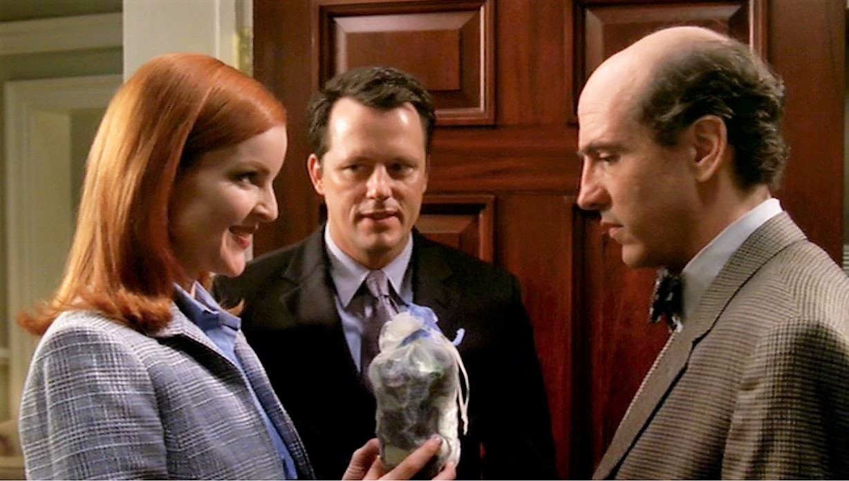
Fig. 2. Bree, her husband Rex, and their marriage counsellor Albert Goldfine (DH1).
Curiously, Bree is an Irish name that means «power» and, as Michel Foucault would say, where there is power, there is also resistance (1978: 95). Her distinguishing feature is the elaboration of her own pastries and sophisticated dishes, mainly of European origin. Cooking is her universe; it brings her pleasure and harmony. Aware of the fact that food can serve to strengthen family ties, she opts for preparing delicious dishes such as osso bucco, chicken saltimbocca, lamb leg stew (Irish stew), basil purée, roast turkey, frittatas, or orange duck. In The Anthropology of Food and Body: Gender, Meaning and Power, Carole Couniham recalls Roman banquets and states that food is central to biological and social life.
We ingest food over and over again across days, seasons, and years to fill our bellies and satisfy emotional as well as physical hungers. Eating together lies at the heart of social relations; at meals we create family and friendships by sharing food, tastes, values, and ourselves (Couniham 1999: 6).
However, Bree’s teenage children, Danielle and Andrew, fail to understand either their mother’s almost obsessive penchant for cuisine, or the cultural dimension that food entails, even suggesting Bree to choose to cook a simple pea purée, since to them it would be acceptable or even more appealing than the most elaborate recipe, inherited from her mother or grandmother. As an example, we are going to reproduce part of the dialogue that takes place in the Van de Kamps’ dining room [fig. 3], a scene in which we can detect a nod to Lester Burnham’s family in American Beauty (Sam Mendes, 1999), in which Janie, the teenage daughter, asks her mother: «Mom, do we always have to listen to this elevator music?». And Carolyn replies, «No. No, we don’t. And as soon as you have prepared a nutritious yet savoury dinner that I’m about to eat, you can listen to whatever you like».
Danielle: Why can’t we ever have normal soup?
Bree: Danielle, there is nothing abnormal about basil purée.
Danielle: Just once, can we have a soup people have heard of? Like French onion or navy bean?
Bree: Your father can’t eat onions. He’s deathly allergic. And I won’t dignify your navy bean suggestion. So, how’s the osso bucco?
Andrew: It’s OK.
Bree: It’s OK?
Bree: Andrew, I spent three hours cooking this meal. How do you think it makes me feel when you say, «It’s OK» in that sullen tone?
Andrew: Who asked you to spend three hours on dinner?
Bree: Excuse me?
Andrew: Tim Harper’s mom gets home from work, opens a can of pork and beans, and they are eating, everyone’s happy.
Bree: You’d rather I serve pork and beans?
Danielle: Apologize now, I’m begging.
Andrew: Do you always have to serve cuisine? Can’t we ever just have food.
[…]
Andrew: Mom, I’m not the one with the problem here. You are the one acting like she’s running for Mayor of Stepford.

The food ritual is elevated to the category of liturgy when the meals are accompanied by classical music. This ceremony is not shared by her children, who reject it; they find no pleasure in the dish that demanded days and hours of preparation. It brought the family together at the dinner table; nevertheless, harmony could not be achieved – only rupture and fragmentation. Although eating what you want to eat might cause a euphoric state that boosts relationships and ties between diners, it is also true that the act of eating can be unpleasant and gruelling if relationships are not good. Let us remember Couniham´s statement:
Because eating good food when hungry causes a euphoric feeling, feasts and meals are a wonderful way to create positive social relations. Similarly, when social relations are bad, eating can be painful and unpleasant (1999: 6).

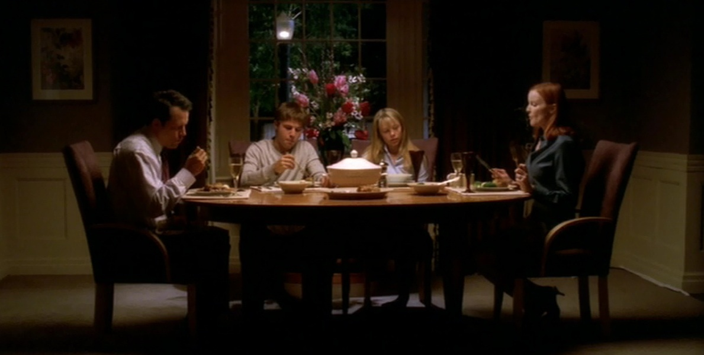
Fig. 3. Food vs. cuisine, an unresolved debate at the Van de Kamps’ dinner table (DH1).
Food also plays an important role in Virginia Wolf’s novel To the Lighthouse (1927). She takes hold of dinner parties to bring the characters together and expose gender issues. The main characters, Mrs Ramsay and Lily Briscoe, follow different paths on their search for meaning. Mrs Ramsay embodies the traditional female gender role; she is fulfilled by her children and hopes to see them married. Lily Briscoe represents the independent, modern woman who rejects traditional Victorian values and strives for meaning in art. Even though Mrs Ramsay seems to be content with the role she has chosen, she can’t help but wonder:
But what have I done with my life? thought Mrs Ramsay, taking her place at the head of the table [. . .] «William, sit by me», she said. «Lily», she said, wearily, «over there». [...] – she [had] only this – an infinitely long table and plates and knives. (Wolf 1977: 78)
Despite the obvious differences in space and time, Bree, too, might ask herself, if all life had in store for her was an infinitely long table with mid-century glassware, porcelain bowls and cutlery. She puts a lot of effort into giving her children the best possible education and spares no effort when it comes to her personal universe. However, her sacrifices will not be duly recognized or appreciated by Rex, Andrew, and Danielle, who understand her impeccable housewife behaviour as an «obsessive compulsive disorder» in her personality.
The 21st century homes in this series are, in most cases, no longer idyllic spaces where one takes refuge; they are instead turned into battlefields: Rex will ask for a divorce and her son Andrew will do everything in his power to not live with her. What are the reasons why domestic chores have never been valued or properly rewarded? Who has laid the foundations for this situation to be carried on over and over and is also the cause of the endless anxiety that resonates with Bree in the series? Is an answer even possible? When Bree visits her marriage counsellor, the therapist and doctor Alfred Goldfine, she seizes the opportunity to slam Sigmund Freud in a tirade and, at the same time, justify her pent-up anxiety.
Bree: […] I took Psychology. We learned all about Freud. A miserable human being.
Goldfine: What makes you say that?
Bree: Think about it. He grew up in the late 1800s. There were no appliances back then. His mother had to do everything by hand. Just back-breaking work from sunup to sundown. Not to mention the countless other sacrifices she had to make to take care of her family. And what does he do? He grows up and becomes famous, peddling a theory that the problems of most adults can be traced back to something awful their mother has done... She must’ve felt so betrayed. He saw how hard she worked. He saw what she did for him. Did he even ever think to say thank you? I doubt it (DH1: 2).

By defending Freud’s mother from the unfair criticism of a traditional patriarchal society, Bree is defending herself: slow but steadily, we are shown the complexity of a character that is neither passive nor submissive like the ideal housewife, sold by the media in the 1950s. She evolves as a character and starts showing us her strength, her resistance, and her strategies to face moments of crisis. Although Bree is more than aware of «needing to live the lie of the image» and «offers us lessons in the politics of appearances» (McCabe 2006: 75-76), her feelings reveal a feminist sensitivity. Her kindness and contained self-control, combined with some of her actions, point to a dark, mysterious, somewhat sinister side whose existence is perhaps not serendipitous, but totally justified, in order to conspire against and deconstruct certain privileged cultural foundations, that do not benefit women at all.
When problems arise and her personal world falls apart, cooking serves as therapy and acts as a brake against a certain feeling of guilt. The culinary tours will be a new evasion strategy, a chance to enjoy avoiding the monotony and day-to-day problems. Trying different dishes with the local pharmacist, George Williams, with whom she shares a taste for opera, music, food, poetry, art, and gardening, will be a new adventure that holds surprises, which may be pleasant... or not [fig. 4].
Bree: George, you have got to taste this. A little messy but…
George: I can’t wait. Is that fennel seed? It’s fantastic.
Bree: I don’t know, but anything that good has to be sinful.
George: Isn’t this fun, trying different dishes and opening up to new experiences?
Bree: Rex just hates these cook tours. He likes to stay at home with a plate of spaghetti and a mug of root beer (DH1: 21).

Good food invites us to an aesthetic experience in which diners savour delightful dishes with gusto, in a pleasant, thoughtful, and selfless way. The act of eating can be defined as a «guilty pleasure»: food becomes a vehicle for and the manifestation of temptation. The culinary tours had started as a game, a hobby, without Bree being aware of their extent: culinary encounters, the types of foods to consume, how and with whom, reveal demeanours that may or may not be appropriate according to the traditionally accepted social code of conduct.
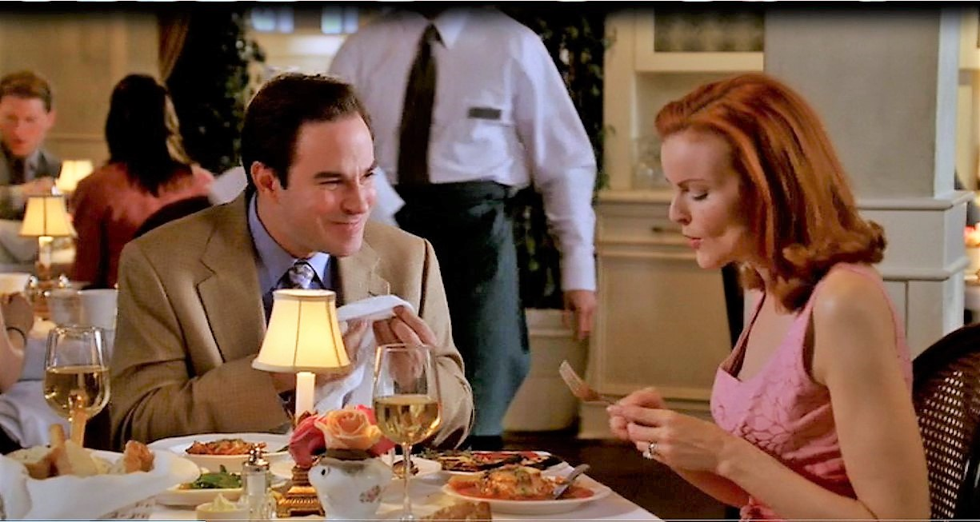
Fig. 4. Bree and George Williams sampling different dishes (DH1).
When her husband Rex, who had always refused to eat the reheated leftovers of the previous day’s meal, asks for a divorce at a cheap steakhouse after reprimanding her that: «I just can’t live in this detergent commercial anymore» (DH1: 1), he is not aware at all that: 1. During the time they’re apart, he will have to get used to eating burritos, frozen pizza, hamburgers, or fried chicken legs from Burger King. 2. From that moment on, his life is in danger since he has unknowingly criticized/exposed the tyranny of the American woman ideal that the media have worked on so hard to promote. According to Janet McCabe:
No wonder he has to die [Rex]… So privileged is what Bree represents in the text as feminine body and female subject… that it comes as little surprise that Rex is inadvertedly killed off at her hands. […] [She] also functions to police the text for any transgressions that challenge what she embodies as representations (2006: 77).
It is crystal clear that Rex has no future, because, as in George Eliot’s novels, any character that represents/causes suffering or inflicts any type of oppression and injustice against women will be punished. Rex has hidden a secret that causes suffering and will completely destabilize the family unit: he has a mistress. Once the lover with whom he practiced sadomasochism is made public, there is no going back. The countdown has started. There will be a certain degree of sympathy but no salvation.
Although her public persona (her perfect theatrical performances) shows no trace of unhappiness, her «true self», the one who hides behind the mask, is prey to fear, helplessness and frustration. That «hidden self» will gradually surface and confess that she has never considered herself the perfect housewife, that she considers herself a total failure in her role as a mother and wife. If she does not abandon her shield of self-control and stiffness, if she remains silent, it is for fear of becoming vulnerable. Her fear of criticism («what will they say?») will scatter by sharing confidences. She is no longer alone, there are many «desperate» women who «bear their suffering», who experience the contradictions of living between two worlds. While some husbands in fictional stories faint (Gilman, 2003: 160), in Marc Cherry’s series, Bree’s first husband passes away (DH1: 23).
3. The artistic dimension of Bree Van de Kamp’s culinary skills
In the second season that starts with Rex’s funeral, the archetype of the perfect housewife is increasingly left in the background: the dark, sinister side comes to the foreground as Bree becomes the main suspect because of the note her husband penned before he passed away. This will lead to Bree breaking her silence:
My husband, the man I spent my life with for 18 years, died thinking that I murdered him. […] The cardiologist shared this moronic theory with Rex, and Rex believed him. […] because he left a note, and it said, and I quote, «Bree, I understand, and I forgive you». I spent 18 years of my life with this man. How could he not know me? […] I have done nothing to be forgiven for! I was a fantastic wife! When he was sick, I nursed him. When we were low on money, I stayed within a budget. I cooked his meals. I mended his clothes. For the love of God, I used to check his back for acne! And that miserable son of a bitch has the nerve to understand and forgive me? Well, the joke’s on him because I do not understand, and I do not forgive! (DH2: 5).
These words reveal a moment of crisis in Bree’s life. This epiphany heralds the beginning of rebuilding herself without leaving behind part of her identity: her passion for cooking. Although her assorted homemade muffins, saddlebag pancakes, and breakfast cookies will continue to be famous, Bree will make certain concessions like buying some croissants for her son Andrew to show him her support and gain his friendship after his coming out (DH2: 11). Or buying for her daughter Danielle a pizza with Canadian bacon to cheer her up (DH2: 13). These exceptions mean ignoring a series of rules and principles: we see a friendlier and more flexible face, despite her being in favour of a healthy and balanced diet. But is it possible to give a nod to good and healthy eating habits? Maybe yes, and that’s why on Andrew’s breakfast tray, next to the croissants from the supermarket, she won’t be able to resist the temptation to include freshly squeezed orange juice as well as some freshly cut and peeled fruit. We will not find on her shopping list cheese macaroni by Kraft, burritos, or frozen pizza that her neighbour and friend Susan Mayer buys and consumes; no corn pancakes or frozen tamales that are not lacking in Gabrielle Solís’ house. Neither industrial pastry donuts with which Edie tries to seduce Mike Delfino, nor fish fingers that Lynette Scavo’s children love so much. It is important to Bree that the vegetables, fruit, meat, or fish consumed at her home are fresh, and when she prepares her dishes, she insists that the ingredients must be of the highest quality.
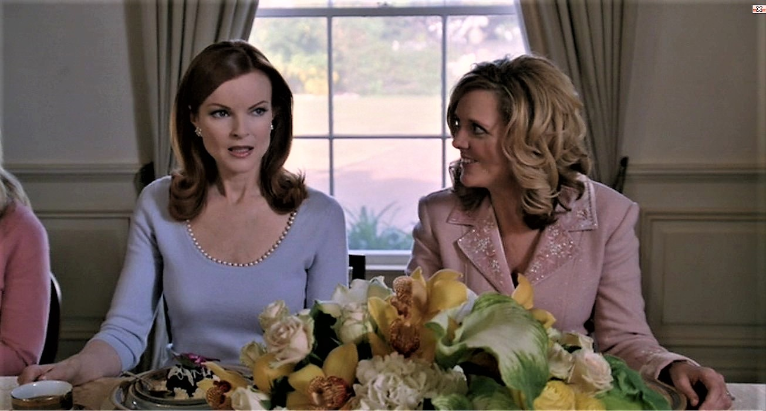
Fig. 5. Bree knew that the pudding was the key to solve a case of illegal slavery (DH2).
Bree is so skilled and talented in the kitchen that it may be said that she capitalizes on the idea that women can be more than just basic cooks, that they can do more than just feed the family, that women can cook artistically. She reminds us of Julia Child, who is considered the mother of American cuisine and broke the rules by creating a hybrid kitchen, a mix between innovation and tradition, and of American businesswoman Martha Stewart, who triumphed with her lifestyle and cooking business. None of them see cooking as an obligation; they understand it in terms of nourishment, art, and pleasure. Being in the kitchen is not slavery but an act of artistic creation. Sure enough, spending hours and hours testing to find the perfect recipe would not be a waste of time for Bree Van de Kamp, Julia Child, or Martha Stewart; they would rather think of it as an enjoyable challenge that they would willingly accept. If someone’s creativity transforms food into a work of art, Bree is an artist, and we should remember that the best Chefs are often called «artists».
Due to her calling and love of creating exquisite dishes, it can be said that Bree’s cooking is a form of edible art. She mixes colours and textures; she adds a slight drizzle of sauce; she pops a small garnish on top; and the result will be cohesive and nutritious dishes that neighbours and friends will certainly love. She knows perfectly well how much time to spend, for example, on preparing a six-course menu for twelve people. That could be the reason why she will be the perfect detective [fig. 5] in season 2, in order to solve a case of illegal slavery since she was the only one who knew that the key to solving the case was in the pudding (DH2: 14).
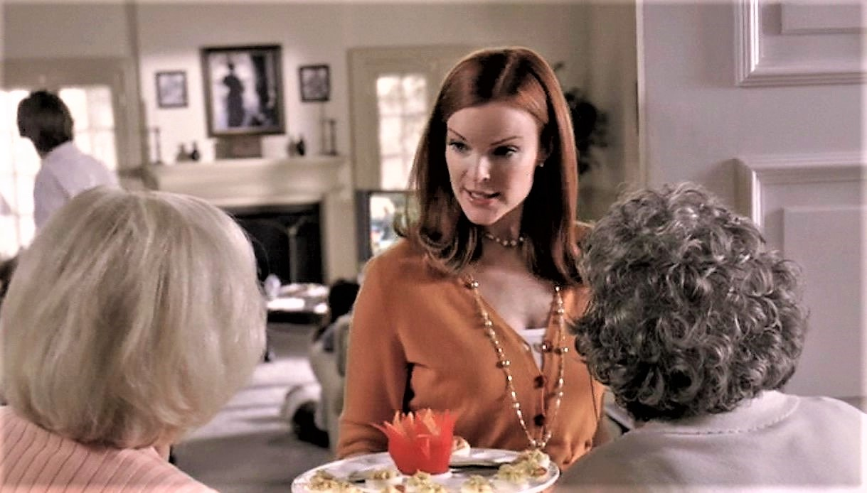
Fig. 6. There is never a lack of food at Bree’s house (DH3).
When in the third season, the supermarket closes down due to a kidnapping [fig. 6], the whole neighbourhood goes to Bree’s house because there is never a lack of food. But if the situation drags on and supplies run out, she is the one that knows how to transform a baguette from the previous day into a delicious bruschetta (DH3: 7). And in the event of any of her neighbours want to impress their guests, they will turn to Bree to get her to cook delicious meals such as blanquette de veau (veal in red wine with mushrooms) and a Grand Marnier soufflé because if you are not good at cooking, the only alternative would be to go to the Red Panda or Shanghai Panda (the Chinese restaurants in the neighbourhood), to buy some spring rolls, special fried rice, noodles or a chicken with almonds (DH3: 10).
4. A new Martha Stwart has settled in the neighbourhood!
In the first episode of the fourth season, Katherine Mayfair (Dana Delany) returns to the neighbourhood with her husband and daughter and settles in the same house where she lived twelve years ago. Katherine, besides growing her own vegetables, is an excellent cook. Trying to encourage and entertain Lynette in her fight against cancer, Bree, Susan, Gabby, and Katherine organize a luncheon. Susan will bring the drinks, Gabby a vegetable lasagne, Bree her star dessert –a lemon cake with meringue– and Katherine is advised to bring a salad (DH4: 2). However, the new neighbour will not be satisfied with preparing a simple starter: she will prepare an exquisite salad of lamb’s lettuce, endive, duck jam and caramelized walnuts. She will also make her own lemon cake with meringue without telling anyone, a dessert that she will serve after hiding Bree’s. After having their pick, everyone present agrees that it is the best cake they have tasted so far – all except Bree, who, after relishing on it, immediately recognizes not to be hers. Katherine reveals that it is her confection, thus stealing the spotlight and stripping Bree of her trademark identity. A new Martha Stewart has settled in the neighbourhood and Bree feels threatened: «she will have stolen my entire identity. […] The only thing about me that’s special is what I can do in the kitchen». And by sharing confidences with her second husband (Orson Hodge), he will define the situation as «culinary terrorism» (DH4: 2).
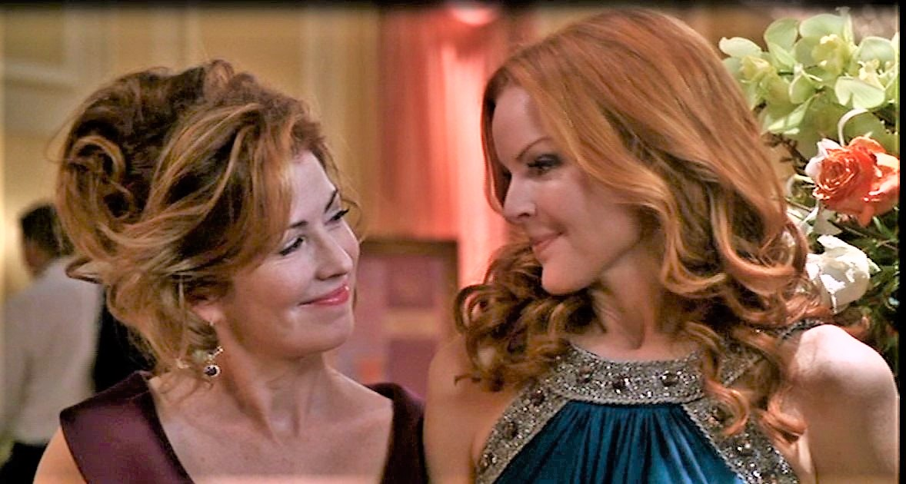
Fig. 7. Bree and Katherine Mayfair work together in a catering business (DH4).
Nevertheless, over time, she will move beyond the idea that there is not room for more than one great cook in the fictional neighbourhood of Wisteria Lane. Therefore, the rivalry between Katherine and Bree will result in friendship and collaboration in a lucrative project [fig. 7] that involves the improved and refined version of the one character who saw her identity threatened: Bree comes across the private sphere to the public one, and she will even find success as a businesswoman with her associate. Her perfectionism will win her the Chamber of Commerce award for «best businesswoman of the year» for her Bree Van De Kamp catering business. Cooking takes time and is somewhat complex, but Bree goes to great lengths to create her «art pieces» in facilities, where she works with the newest equipment.
Another one of her projects that she is wholeheartedly committed to is writing her book Traditional American Food by Bree Van De Kamp. 125 Simple and Delicious Recipes. Her life project is shaking up: she goes from a quintessential housewife to a hard-working businesswoman. She is interviewed on the radio; she is invited as a guest in a television program. She holds a cooking demonstration in a mall. Her eventual success outside the home is a direct result of professionalising a typically ‘feminised’ occupation. What was once a hobby, a form of therapy and escapism, allows her to support her family. The irony is that her stressful schedule prevents her from cooking for her second husband (Orson Hodge), who we will see sitting at a table eating food from the Chinese restaurant from the neighbourhood [fig. 8], while listening to his wife being interviewed on the radio (DH5: 2).
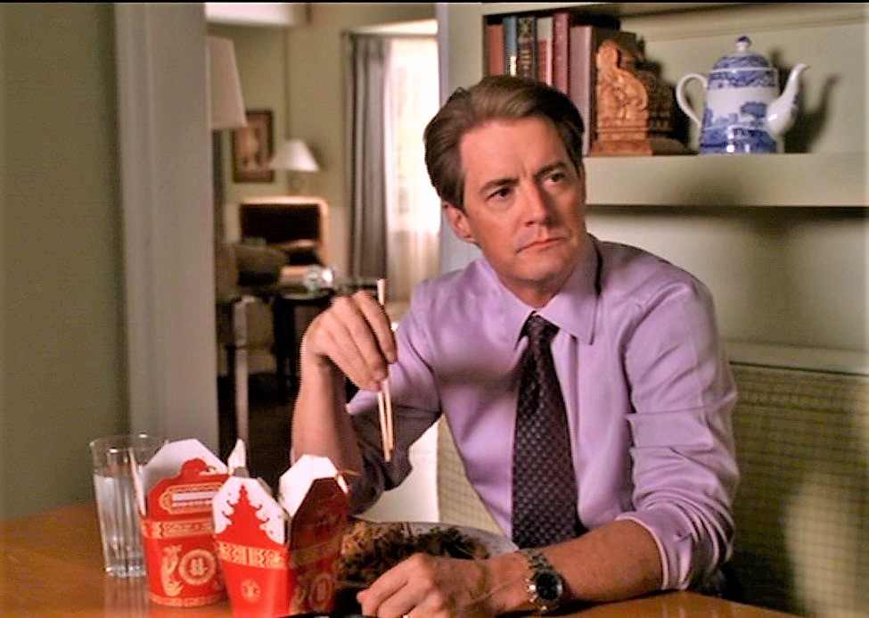
Fig. 8. Bree’s second husband, Orson Hodge, eating Chinese food (DH5).
Every success brings some heartache. When a journalist from the New York Dispatch interviews her on the occasion of the book launch, she will harshly criticize the recipe book as «a total sham, a scam» as, in her opinion, it is a book «designed to make every woman who reads it feel like a failure, if she doesn’t measure up». Bree defends herself against these accusations by assuring the journalist that her book is neither a scam nor a sham, but a «lifeline», because she does not think that she is «wonderful or perfect» and even admits that she has lost count of the times she has failed, and who, like other women, is «just barely holding on» (DH5: 8). Yes, her cookbook is a «lifeline» that she wants to share with other women, to give them tips on how to run a household, how to talk about traditional values; but above all, she wants women to know that there is another dimension that food offers: its healing nature and that there is always the possibility of doing something right, even if it is only a stew or a casserole.
Is the act of cooking itself physically and/or mentally healing? At present, it seems that an increasing number of people are viewing the kitchen as a safe and meditative space where they can work on their mental well-being. The months of lockdown have seen more bread loaves emerge from the ovens than ever before. It seems that culinary therapy has become a trend because of the coronavirus pandemic. A study in The Journal of Positive Psychology found that those who were regularly engaged in creative activities such as cooking, or baking, found gratification in creating something new. According to Michael M. Kocet, professor at the Chicago School of Professional Psychology, culinary therapy «uses cooking, gastronomy and an individual’s personal, cultural and familial relationship with food to address various emotional and psychological problems». For Kocet,
[…] We’re feeling a loss of control as our routines are thrown out the window. Cooking can centre people, offering the emotional grounding of a task and a sense of accomplishment […] the comforting link between food and memories, the calmness that can be created by the rhythm of cooking, and the sense of control that can be gained from organising your ingredients. Even if you aren’t able to share a meal in person anymore, you could start a virtual cooking club or leave a dish on your neighbor’s doorstep.

We wonder whether Bree’s catering business would have been flexible or not to adapt itself to customer demands during the coronavirus pandemic. We have talked about Bree’s adaptability that ranges from preparing an anniversary party, a wedding banquet, or writing a book about traditional American food [fig. 9] to catering the celebration of the Jewish rite of passage called bar mitzvah, the moment in which young men are held responsible for their actions. She is always open to new culinary experiences, but she is not aware that serving «bacon-wrapped shrimp puff» or «shrimp with bacon» at a Jewish ceremony can be considered a sign of disrespect. What made her think that «if they’d tasted mine, they might change the rules»? (DH5: 15) Is it an example of Bree’s limited view of what is correct? Is it an example of a peculiar sense of humour that simply reveals American society’s contradictions? Lévi-Strauss reminds us that food preparation can be analysed as a triangular semantic field.

Thus, we can hope to discover for each specific case how the cooking of a society is a language in which it unconsciously translates its structure –or else resigns itself, still unconsciously, to revealing its contradictions (2008: 43).

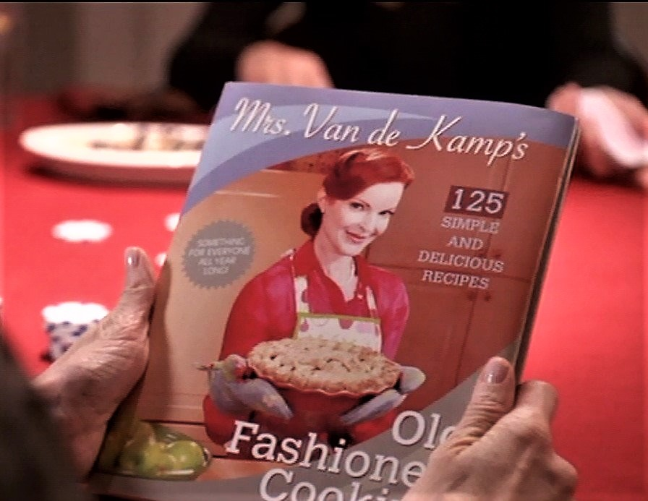
Fig. 9. Bree’s book about traditional American food and values (DH5).
5. Conclusion
In «Deciphering a Meal», Mary Douglas asserts that «the ordered system which is a meal represents all the ordered systems associated with it» (2008: 52). The culinary universe of Bree Van De Kamp is a fictional and law-abiding locus amoenus rich in cultural nuances and exquisite recipes, since it seems to embrace the diversity of French, Italian, British, Polish, or Mexican cuisine. In trying to portray diversity, it becomes a hyper-real universe, or in Baudrillard’s words: «more real than real». As a perfectionist and restless fighter, she goes to great lengths to maintain her identity and an authenticity marked in part by her adherence to European cultural roots.
Trapped in the webs of this illusion, we do not know if she will be able to avoid the confusion and pitfalls of all the criteria and senses, or if she will be able to take advantage of it. The one thing we can be certain about is that she will stick to her principles: she will refuse to serve packaged food, frozen pizza or industrial pastries at her table, but she will have to come to terms with the idea that her precious cultural heritage will not be enjoyed by her grandson who, while still being a growing child, is already on a «vegetarian» menu which, in Barthes’ words, is «an attempt to copy the appearance of meat dishes based on a series of artifices» (2008: 35). Will Bree cook nourishing, vegetarian meals such as hearty quesadillas or a vegan chocolate layer cake, taking into consideration moods and occasions? She could follow Deborah Madison’s, Alice Hart’s or Del Sroufe’s steps; that is, she could combine ingredients and present vegetarian or vegan dishes with style, taste, and enjoyment in mind. Her culinary skills are excellent; therefore, she can turn a dull vegetarian or vegan dish into a creative, healthful, and passionate meal that will certainly awaken and appeal her grandson’s senses.

Bibliography
Akass, Kim (2006) «Still Desperate After All These Years: The Post-feminist Mystique and Maternal Dilemmas». In: Reading Desperate Housewives. Beyond the White Picket Fence. London & New York: I.B. Tauris, 48-58.
Alberola Crespo, Nieves (2012) «Una definición polémica: la identidad femenina». In: Rosalía Torrent y Sonia Reverter (eds.) Variaciones sobre género. Castellón: ACEN, 43-54.
Bailey, Mashama & Morisano, John O. (2021) Black, White and the Grey. The Story of an Unexpected Friendship and a Beloved Restaurant. New York: Lorena Jones Books.
Barthes, Roland (2008) «Toward a Psychosociology of Contemporary Food Consumption». In: Carole Counihan & Penny Van Esterik (eds.) Food and Culture. A Reader. New York & London: Routledge, 28-35.
Baudrillard, Jean (1987a) Cultura y simulacro. Barcelona: Editorial Kairós.
— (1987b) América. Barcelona: Anagrama.
Chambers, Samuel A (2006) «Desperately Straight: The Subversive Sexual Politics of Desperate Housewives». In: Reading Desperate Housewives. Beyond the White Picket Fence. London & New York: I.B. Tauris, 61-73.
Couniham, Carole (1999) The Anthropology of Food and Body: Gender, Meaning and Power. New York: Routledge.
Coward, Rosalind (2006) «Still Desperate: Popular Television and the Female Zeitgeist». In: Reading Desperate Housewives. Beyond the White Picket Fence. London & New York: I.B. Tauris, 31-41.
Douglas, Mary (2008) «Deciphering a Meal». In: Carole Counihan & Penny Van Esterik (eds.) Food and Culture. A Reader. New York & London: Routledge, 44-53.
Faludi, Susan (1993) Reacción. La guerra no declarada contra la mujer moderna. Barcelona: Anagrama.
Fluke, Joanne (2000) Chocolate Chip Cookie Murder. New York: Kensington.
— (2008) Carrot Cake Murder. New York: Kensington Books.
Foucault, Michel (1978) The History of Sexuality. Volume I. New York: Pantheon Books.
Gershman, Liza (2021) County Fair: Nostalgic Blue-Ribbon Recipes from America’s Small Towns. New York: Images Publishing.
Gilman, Charlotte Perkins (2003) «El empapelado amarillo». In: Nieves Alberola Crespo y Carme Manuel i Cuenca (eds.) Voces proféticas. Relatos de escritoras estadounidenses de entresiglos (XIX-XX). Castellón: Ediciones Ellago y Publicaciones de la Universitat Jaume I, 141-160.
Greer, Germaine (2005) «Haunted by the Ghost of Martha Stewart». The Guardian, 3/1/2005. http://www.theguardian.com/media/2005/jan/03/television.artsfeatures.
Hart, Alice (2016) The New Vegetarian Book. London: Penguin Random House.
Lavery, David (2006) «`W´ stands for women, or is it Wisteria? Watching Desperate Housewives with Bush 43». In: Reading Desperate Housewives. Beyond the White Picket Fence. London & New York: I.B. Tauris, 17-30.
Lévi-Strauss, Claude (2008) «The Culinary Triangle». In: Carole Counihan & Penny Van Esterik (eds.) Food and Culture. A Reader. New York & London: Routledge, 36-43.
Madison, Deborah (2014) The New Vegetarian Cooking for Everyone. New York: Broadway Books
McCabe, Janet & Akass, Kim (eds.) (2006) Reading Desperate Housewives. Beyond the White Picket Fence. London & New York: I.B. Tauris.
McCabe. Janet & Akass, Kim (2006) «Introduction: Airing the Dirty Laundry». En: Reading Desperate Housewives. Beyond the White Picket Fence. London & New York: I.B. Tauris, 1-14.
Monroe, Shawnthea (2006) Not-So-Desperate: Fantasy, Fact, and Faith on Wisteria Lane. St. Louis, Missouri: Chalice Press.
Singer, Peter (2020) Why Vegan? Eating Ethically. New York & London: W.W. Norton and Company.
Sroufe, Del (2012) Forks over Knives – The Cookbook. Over 300 Recipes for Plant Based Eating All Through the Year. New York: The Experiment, LLC.
Stanley, Alexandra (2004) «TV Watch: Old Time Sexism Suffuses New Season». The New York Times, October 1, 2004. http://www.nytimes.com/2004/10/01/arts/television/ 01TVWK.html.
Styler, Christopher & Tobis, Scott S. (2006) The Desperate Housewives Cookbook. Juicy Dishes and Saucy Bits. New York: Hyperion Books.
Wilson, Leah (2006) Welcome to Wisteria Lane: on America’s Favorite Desperate Housewives. Dallas, Texas: Benbella Books.
Wolf, Naomi (1991) The Beauty Myth: How Images of Women are Used Against Women. London: Vintage.
— (1993) Fire with Fire: The New Female Power and How it Will Change the 21st Century. London: Chatto & Windus.
— (2001) Misconceptions: Truth, Lies, and the Unexpected on the Journey to Motherhood. New York: Anchor Books.
Wolf, Virginia (1977) To the Lighthouse. St. Albans, London: Triad/Panther Books.

Videography
Desperate Housewives. First season. Original airdate: October 3, 2004; last episode aired: May 22, 2005. DVD Video, Buena Vista Home Entertainment y Touchstone Television, 2005.
Desperate Housewives. Second season. Original airdate: September 25, 2005; last episode aired: May 21, 2006. DVD Video, Buena Vista Home Entertainment y Touchstone Television, 2006.
Desperate Housewives. Third season. Original airdate: September 24, 2006; last episode aired: May 20, 2007. DVD Video, Buena Vista Home Entertainment y Touchstone Television, 2007.
Desperate Housewives. Fourth season. Original airdate: September 30, 2007; last episode aired: May 18, 2008. DVD Video, Buena Vista Home Entertainment y Touchstone Television, 2008.
Desperate Housewives. Fifth season. Original airdate: September 28, 2008; last episode aired:May 17, 2009. DVD Video, Buena Vista Home Entertainment y Touchstone Television, 2009.
Desperate Housewives. Sixth season. Original airdate: September 27, 2009; last episode aired: May 16, 2010. DVD Video, Buena Vista Home Entertainment y Touchstone Television, 2010.
Desperate Housewives. Seventh season. Original airdate: September 26, 2010; last episode aired: May 15, 2011. DVD Video, Buena Vista Home Entertainment y Touchstone Television, 2011.
Desperate Housewives. Eighth season. Original airdate: September 25, 2011; last episode aired: May 13, 2012. DVD Video, Buena Vista Home Entertainment y Touchstone Television, 2012.

Wisteria is a pretty plant but also a twining vine that spreads and kills other plants in a garden.
«Desperate Housewives is an upper-middle-class drama. The neighborhood and the houses are part of a vision of affluent suburbia that Americans idealize. From a statistical standpoint, very few of us live or can ever hope to live in such a lovely environment. But we seem to all have a vision of what constitutes the good life –and it looks a lot like Wisteria Lane» (Monroe 2006: 11).
«Something about the show has succeeded in appealing to viewers across every demographic –despite featuring a handful of largely white, upper-middle class housewives in the suburbs» (Wilson 2006: 2).
Marc Cherry was a producer and screenwriter on The Golden Girls and its sequel The Golden Palace, as well as the creator and co-creator of The 5 Buchanans, The Crew and Some of My Best Friends. After finishing four seasons of Devious Maids for Netflix, he started working on Why Women Kill, which was renewed for a second season, before the first one even concluded, and a third season was renewed in December 2021.
On February 2, 2005, the article was published in the Daily Mail: «Laura Bush: I’m a Desperate Housewife» by Jacqui Goddard. http://www.dailymail.co.uk/news / article-347045 / Laura-Bush-Im-Desperate-Housewife.html. Accessed April 2, 2013. Retrieved on April 2, 2013.
For a brief note on Ira Levin’s novel and its film adaptations (1975 and 2004) in the context of feminism, see Alberola Crespo (2012: 51-52).
Donna Reed (1921-1986) is remembered for her film work on classic movies like It’s a Wonderful Life (1946) and From Here to Eternity (1953) for which she was awarded the Oscar for best supporting actress. She worked on television on the program The Donna Reed Show (1959-1966) in which she played the American middle-class housewife and for which she was nominated for an Emmy Award for four consecutive years.
In 1986 Faith Popcorn coined a new term «cocooning»: «It was the national trend of the 80s […] We are becoming a nation of nesters. […] We prefer to stay at home and take care of our nest. The traditional dishes of our mothers, such as chicken pie or roasted beef, are back in fashion». Her customers in the food industry warmly supported these statements. An enthusiastic Pillsbury spokeswoman told Newsweek, «I believe in cocooning» (Faludi, 1993: 121).
At the end of this scene, Bree offers her companion clams that have long been considered food with an aphrodisiac quality and a metaphorical symbol for the vagina. With this act, she reveals herself as the embodiment of temptation, as a She-Devil. «The new Lilith» will awaken the darkest and most sinister side of the pharmacist.
Julia Child (1912-2004) attended the classes of a renowned French chef, Max Bugnard, at his famous Cordon Blue school (1949-1950).
Martha Stewart (1941) started a catering service in 1976 that soon became very popular. She is the author of several books published in the 1980s.
In Joanne Fluke’s novel Chocolate Chip Cookie Murder (2000), the protagonist Hanna Swensen makes cookies and uses them as a business card to obtain information and solve a murder case. In Carrot Cake Murder (2008), for the same purpose of solving a crime, she will cook sweets that will help a patient with Alzheimer’s to remember.
In 2021 Mashama Bailey and John Morisano published Black, White and the Grey. The Story of an Unexpected Friendship and a Beloved Restaurant, a true story about a Chef and an entrepreneur, how they went from business partners to dear friends, hoping to bridge biases and get people talking about gender, race, class, and culture.
Michael Kocet quoted in https://www.naturalhealthwoman.com/the-healing-power-of-cooking and in https://www.eatingwell.com/article/7805560/why-people-are-cooking-to-help-relieve-stress-during-the-coronavirus-pandemic/
This mirage of accepting anything different contrasts with Susan Mayer’s rejection of a wedding cake that symbolizes British culture and with her rejection to consume Macadamia nuts of Australian origin which is now growing throughout Hawaii, California, Florida, Guatemala, South Africa, and Kenya. As for Gabrielle, despite enjoying eating Mama Solis quesadillas, she rejects her Aunt Connie’s tamales, since they represent her Mexican roots.
Peter Singer is a vegan philosopher. His Animal Liberation is a seminal book in practical ethics and the animal rights movement. There are of course philosophers who disagree with Singer.

