**Citizen consultations on science communication: a citizen science approach**

**Introduction**

Citizen science is a prominent feature of current relations between science and society. Involving citizens in the production of science is seen as one of the best ways of generating understanding and trust and enhancing communication, but also to make science more attuned to citizen’s needs and concerns.

Like other domains, there are many ways of engaging citizens with science. The levels of engagement are varied, from asking citizens to collect data to involving them in all stages of the research project.

CONCISE is a European funded project[1] that aims to understand how citizens acquire their science-related knowledge, and how this influences their beliefs, opinions and perceptions. By engaging citizens in public consultations and beyond, CONCISE fulfils the tenets of citizen science.

This paper aims to examine the ways in which citizen science has been framed and operationalised in the CONCISE project. A short overview of the literature on citizen science is followed by a succinct description of the project. Next, the procedures of the consultations are examined, as well as further steps of involving the citizens.

**Citizen science: a framework**

The transition from a «public understanding of science» approach, based on a deficit model that attributed distrust of science to ignorance, to a «public engagement with science» approach is well documented (Bucchi and Neresini 2008). Efforts to increase scientific literacy, by «teaching» science to the public, have been gradually (although not completely) replaced with initiatives that promote dialogue between scientists and the public and the participation of stakeholders and citizens in policy decisions alongside technical experts.

Citizen science is part of this transformation of science-society relations. The definition of what exactly constitutes citizen science is under dispute (Heigl et al. 2019). Different disciplinary and national traditions redound in different criteria for ascribing the citizen science label to projects. The 2015 White Paper on Citizen Science defined it as «the general public engagement in scientific research activities when citizens actively contribute to science either with their intellectual effort or surrounding knowledge or with their tools and resources».[2] The European Citizen Science Association considers citizen science «a flexible concept which can be adapted and applied within diverse situations» and defined 10 principles of citizen science, the first of which is «Citizen science projects actively involve citizens in scientific endeavours that generates new knowledge or understanding».[3]

Other concepts have been proposed to define the same activities of involving citizens in scientific research, such as civic, civil, participatory, amateur, stakeholder, community or democratic science, science 2.0, knowledge co-production between lay people and experts, community-based participatory research, or public participation in scientific research (Bäckstrand 2003; Bucchi and Neresini 2008; Shirk et al. 2012).

Three main strands in citizen science can be identified. The first strand concerns mainly the natural sciences, in particular the involvement of citizens in collecting or analysing data in astronomy, earth sciences, botany, and zoology projects (Greenwood 2007; Raddick *et al.* 2009). Similar practices are being used in other areas, such as biodiversity, genetics and agricultural sciences, engineering, or geography (see, for instance, Ellis and Waterton 2004; Cooper *et al.* 2007).

Another strand of citizen science emerged from concerns with environmental contamination and its health effects in the 1970s, especially in the United States, which spurred the formation of community movements that pushed for more research along with new forms of community ownership over scientific evidence (Brown 1997; Heinman 1997). This has been labelled as «popular» or «lay epidemiology», relying on «local» or «experiential» knowledge. It has expanded to several different contexts, such as water and air quality monitoring, investigation of the environmental causes of diseases, or other issues in sustainability science (Heinman 1997; Bäckstrand 2003).

A third tradition of citizen science can be found in the social sciences. Whereas participatory action research is considered a paramount methodology in this field (Reason and Bradbury, 2006), social scientists have contributed to a wide array of engaged action research in domains such as education, children studies, public health, urban planning, and international development(see, for instance, Gendron 1998 or Suarez-Balcazar *et al.* 2005). The role of social sciences has been mainly to pursue goals related to a more effective combination between expert and lay knowledge, as well as the empowerment of local communities.

Citizen science has become in recent years a quasi-autonomous scientific and practice field. It has its own associations or platforms at the international (the Citizen Science Association, the European Citizen Science Association) and national (e.g. the Australian Citizen Science Association) levels. In other cases, science communication associations included citizen science within their areas of activity (e.g. the British Science Association). There are conferences and publications solely devoted to the theme, such as *Citizen Science: Theory and Practice.* Several journals have published special issues dedicated to the topic of citizen science and the Web of Science contains over 3,000 articles about it. The EU-Citizen Science platform lists 110 ongoing citizen science projects. The Spanish Observatory of Citizen Science, run by the Ibercivis Fondation, has identified 236 citizen science initiatives in the country (including the CONCISE project).

Citizen science projects can be classified according to the depth of citizen involvement. For instance, Cooper et al. (2007) proposed a typology of community projects with five types: scientific consulting research (science shops), citizen science research, adaptive citizen science research, adaptive co-management research and participatory action research, Shirk et al. (2012) defined five basic models for Public Participation in Scientific Research:

Contractual projects, where communities ask professional researchers to conduct a specific scientific investigation and report on the results; Contributory projects, which are generally designed by scientists and for which members of the public primarily contribute data; Collaborative projects, which are generally designed by scientists and for which members of the public contribute data but also help to refine project design, analyse data, and/or disseminate findings; Co-Created projects, which are designed by scientists and members of the public working together and for which at least some of the public participants are actively involved in most or all aspects of the research process; and Collegial contributions, where non-credentialed individuals conduct research independently with varying degrees of expected recognition by institutionalized science and/or professionals. (Shirk et al. 2012: 29)

Most citizen science projects remain at the lowest level of citizen engagement: citizens are asked solely to collect data, while scientists carry out the analysis and interpretation, draw conclusions and disseminate results. Citizens are thus ascribed a subordinate role, disregarding local and experiential knowledge, embodied skills, emotions and ethical sensibilities or any contribution that goes beyond data collection within the restricted confines of instruments and protocols defined by scientists (Ellis and Waterton 2004; Cornwell and Campbell 2012). Ellis and Waterton (2004) point out the paradox of involving citizens because expert contributions are insufficient for supporting robust policies and then limiting their involvement by curbing the expression of alternative knowledge and cultural epistemologies and ontologies.

**The CONCISE project**

CONCISE *Communication role on perception and beliefs of EU Citizens about Science* is a research project funded by the European Commission through its Horizon 2020 programme. It is led by the University of Valencia (Carolina Moreno is the project coordinator) and has the participation of four universities across Europe (University of Pompeo Fabra, Trnava University, University of Lodz and the University of Lisbon, through the Institute of Social Sciences), two NGO (Observa and the Spanish Association of Science Communication) and two SME (Danmar Computers and FyG consultants). Therefore, the project involves five countries: Spain, Portugal, Italy, Slovakia and Poland.[4]

CONCISE’s main objective is to learn the role science communication plays on the origin of beliefs, perceptions and knowledge concerning scientific issues. CONCISE investigates the means or channels by which EU citizens acquire their science-related knowledge, and how this knowledge influences their beliefs, opinions and perceptions. Furthermore, CONCISE intends to generate a European-wide debate on science communication, involving a wide array of stakeholders, from media outlets to policy makers, from scientists to business companies, from science communicators to civil society organisations. Last but not least, CONCISE strives to enable active citizen participation in scientific research processes, in line with the concept of responsible research and innovation (RRI).

The core methodological procedure of CONCISE are public consultations with citizens of the five participating countries. It is through these consultations that citizens are engaged in the scientific process, contributing to the production of science by sharing their opinions, perceptions and suggestions to improve science communication.

**The citizen consultations**

The methodological option for citizen consultations, in lieu of the more customary surveys or interviews, is due to the depth of information that can be collected through this procedure. Discussions among citizens allow us to better understand the divergence of opinions and capture the narratives and processes through which citizens build and justify their attitudes and beliefs. It also generates a participatory dynamic that engages citizens in the research process, rather than just collecting information from them.

Based on available literature on participatory methods (see, for instance, the action catalogue developed in the European project Engage 2020[5]) CONCISE developed its own methodology of public consultation. This methodology was tested in a pilot consultation in Barcelona in March 2019, before being improved and applied in all five participating countries between September and November 2019 (see Figure 1).

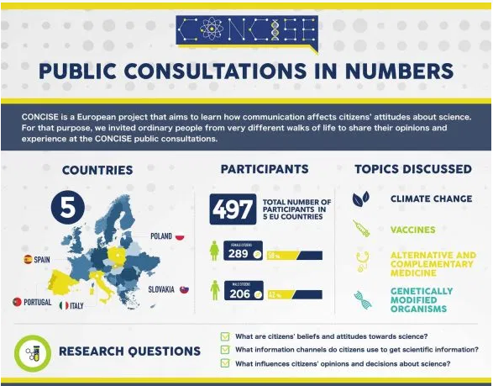

Figure 1: Infographic of the CONCISE consultations, by FyG and AECC

The consultations were designed to involve 100 citizens in each country and to bring them all together for a one-day discussion on science communication. Citizens were divided into groups of 8 or 10 people and allocated to a table, together with a moderator and an observer, who took notes. The discussion was divided into four sessions, each addressing a controversial scientific topic: climate change, vaccines, genetically modified organisms (GMO) and alternative and complementary medicines. No information on the topics was provided to the citizens beforehand nor during the consultations.

In most cases, the locations chosen for the consultation were also meant to convey a sense of neutrality in terms of scientific authority: an 18th century palazzo in Italy, a botanical garden in Spain, a cultural centre in Portugal (see Figure 2).

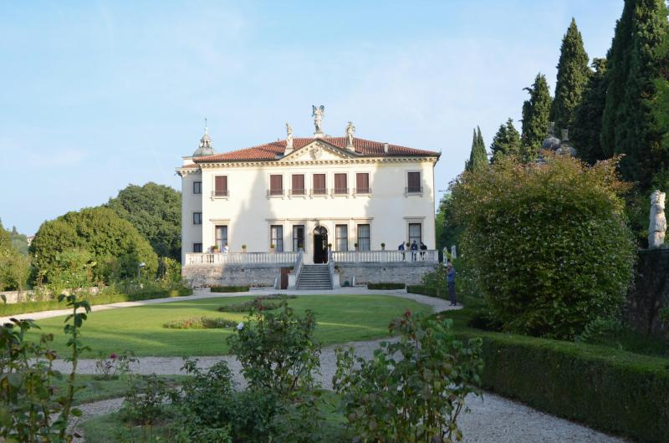

Figure 2 Villa Valmarana ai Nani, Vicenza, the location of the Italian CONCISE consultation, photo by Danmar

The sample of 100 citizens in each country was not meant to be representative of the population of the countries (see the article on recruitment by Mendonza Poudereux and Gaston Estanga in this issue) but rather to be diversified in terms of gender, age, educational level, occupation, and region. It was also meant to be inclusive in terms of nationality, migrant backgrounds and physical disabilities. While the results cannot be extrapolated to the entire population, they show, however, a wide variety of opinions and perceptions over the four topics.

The distribution of citizens by tables was done according to their educational levels. We wanted to create the conditions for the free expression of opinions, without arguments of authority that can emerge in groups where some participants have higher levels of educational attainment. Contrariwise, the tables were heterogeneous in terms of gender and age, to create a more lively and diversified discussion (see Figure 3).

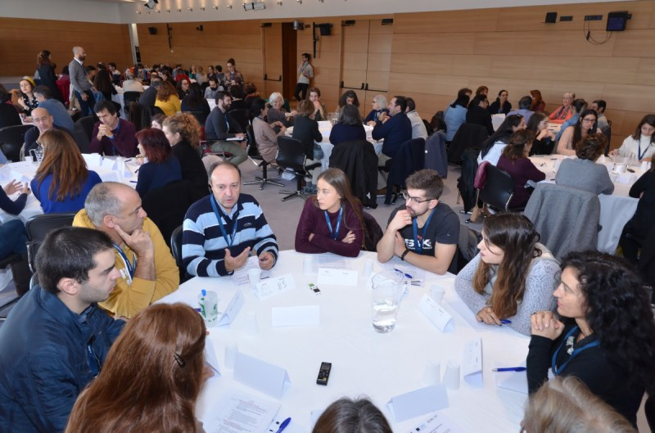

Figure 3 Discussion tables in the CONCISE consultation in Lisbon, photo by Danmar

The discussion at the tables was steered by the moderators following a script designed to address the research questions of the project. For each scientific topic, citizens were asked how they obtained scientific information, how they assessed the reliability of information and sources and whether they performed active searches, and how they would like to receive scientific information. These discussions were audio recorded and transcribed verbatim. After each round of discussions, participants were also asked to take part in a quantitative activity: a short survey on the topic of the discussion in two cases, two questions on general attitudes towards science in another case, and an assessment of online media headlines on the fourth.

The data collected will not only allow to understand how citizens perceive and assess scientific information but also garner their suggestions on how to improve science communication and the presentation of scientific knowledge. The analysis aims at identifying shared ideas by participants in all the citizen consultations about four aspects: message (language, formats); medium (digital media, educational system, traditional media); producers (institutions, scientists, teachers, journalists, science communicators) and target audiences (children, general public, elderly, professionals). The qualitative analysis of the content will allow not only to assess individual perceptions and attitudes (and by gender, age groups, educational level), but also the groups discussions and the interactions between participants.

It is this information provided by citizens that will inform our analysis of the phenomenon and our policy recommendations. Since participants were also asked to give their feedback on the consultation itself, through a questionnaire at the end of the events, their opinions will also help improve the methodology and design more effective ways of engaging citizens in scientific research.

**Next steps in involving the public**

Involving citizens in data collection is the most frequent practice in citizen science, as seen above. CONCISE can be thus considered a contributory project, according to the typology mentioned above. But citizens can and should also participate in other stages of the project, namely to be informed of the results and collaborate in dissemination as well.

The CONCISE team has already produced two kinds of dissemination materials about the process of the consultations aimed at the general public: infographics (see Figure 1) and videos (containing footage of the events and interviews with participants and organisers). The videos were sent to the citizens who participated in the consultations and they, in turn, shared them with their contacts.

Once the data analysis is concluded and research results are ready to be shared and discussed, the CONCISE team will develop different dissemination materials tailored to different audiences: scientific articles for researchers, policy briefs for policy-makers, press releases for media outlets. In all outputs, the collaboration of the citizens will be acknowledged. However, it will also be important to design dissemination materials accessible to a wider audience, including the consultation participants. These materials can be research briefs written in a non-hermetic language, infographics that are clear and easy to understand, videos showcasing the most relevant outcomes of the project.

Citizens will play an important role in the diffusion of the results among their social networks of friends and relatives. It is hoped that the results show ways to fight disinformation, to dismiss fake news and hoaxes, to develop strategies to identify trustful sources of scientific information and base everyday decisions and behaviours on them. And who better to benefit from this information than the general public? Although we intend to issue recommendations to scientists, communicators and policymakers, it is the public who is the true recipient of our research endeavours.

**References**

Bäckstrand, K. (2003). Civic Science for Sustainability: Reframing the Role of Experts, Policy-Makers and Citizens in Environmental Governance. *Global Environmental Politics*, 3(4), 24–41.

Brossard, D., Lewenstein, B., & Bonney, R. (2005). Scientific knowledge and attitude change: The impact of a citizen science project. *International Journal of Science Education*, 27(9), 1099–1121.

Brown, P. (1997). Popular Epidemiology Revisited. *Current Sociology*, 45(3), 137–156.

Bucchi, M. & Neresini, F. (2008) Science and Public Participation. In E. J. Hackett et al., *Handbook of Science and Technology Studies* (pp. 449-472), Cambridge: MIT Press

Cooper, C. B., Dickinson, J., Phillips, T., & Bonney, R. (2007). Citizen Science as a Tool for Conservation in Residential Ecosystems. *Ecology and Society*, 12(2).

Cornwell, M. L., & Campbell, L. M. (2012). Co-producing conservation and knowledge: Citizen-based sea turtle monitoring in North Carolina, USA. *Social Studies of Science*, 42(1), 101–120.

Ellis, R., & Waterton, C. (2004). Environmental citizenship in the making: the participation of volunteer naturalists in UK biological recording and biodiversity policy. *Science and Public Policy*, 31(2), 95–105.

Gendron, S. (1998). La recherche participative: un cas d’illustration et quelques réflexions pour la santé publique. *Ruptures, revue transdisciplinaire en santé*, 5(2), 180–191.

Greenwood, J. J. D. (2007). Citizens, science and bird conservation. *Journal of Ornithology*, 148(S1), 77–124.

Heigl, F., Kieslinger, B., Paul, K. T., Uhlik, J., & Dörler, D. (2019). Opinion: Toward an international definition of citizen science. *Proceedings of the National Academy of Sciences*, 116(17), 8089-8092.

Heinman, M. K. (1997). Science by the People: Grassroots Environmental Monitoring and the Debate over Scientific Expertise. *Journal of Planning Education and Research*, 16(4), 291–299.

Raddick, M. J., Bracey, G., Carney, K., & Gyuk, G. (2009). Citizen Science: Status and Research Directions for the Coming Decade. Astro2010: The Astronomy and Astrophysics Decadal Survey, Position Papers, no. 46.

Reason P. & Bradbury H. (Eds). Handbook of action research: Participatory inquiry and practice (pp.27-37) Thousand Oaks, CA: Sage.

Shirk, J. L., Ballard, H. L., Wilderman, C. C., et al.. (2012). Public Participation in Scientific Research: a Framework for Deliberate Design. *Ecology and Society*, 17(2).

Suarez-Balcazar, Y., Harper, G. W., & Lewis, R. (2005). An interactive and contextual model of community-university collaborations for research and action*. Health education & behavior*, 32(1), 84–101.

1. This project has received funding from the European Union’s Horizon 2020 research

   and innovation programme under grant agreement No 824537.
2. <https://ec.europa.eu/futurium/en/content/white-paper-citizen-science>
3. [www.ecsa.citizen-science.net/sites/default/files/ecsa_ten_principles_of_citizen_science.pdf](http://www.ecsa.citizen-science.net/sites/default/files/ecsa_ten_principles_of_citizen_science.pdf)
4. For more information, see the project website: <https://concise-h2020.eu/>
5. <http://actioncatalogue.eu/>