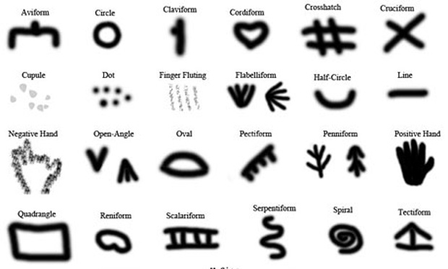Image ideas

Text:

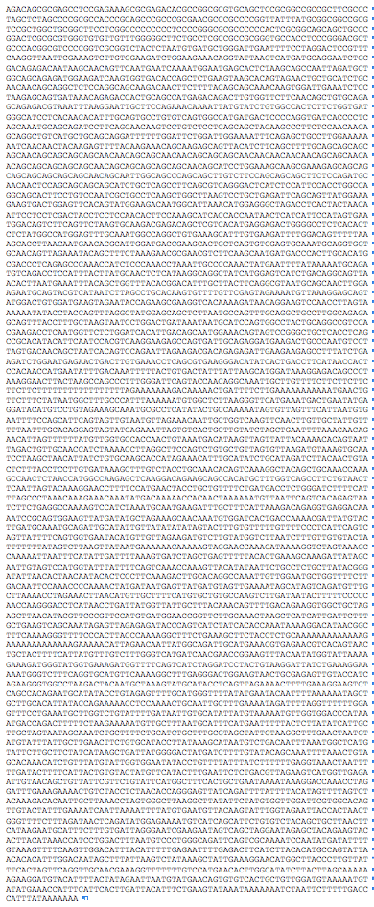When humans started using signs in many different cave paitings around 30 000 years ago – suggesting that they were using them symbolically – the human-specific sequence of the FOXP2 gene was already the same as it is today (photo and research on signs in cave paintings by Genevieve von Petzinger, University of Victoria, British Columbia)

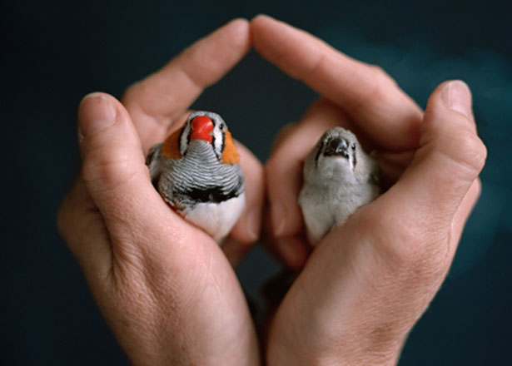

Text: Juvenile zebra finches (right) need to learn to sing not unlike babies need to learn how to speak. Adult males (left) act as tutors and juveniles modify their babbling until the master adult song ‚as good as dad’s’

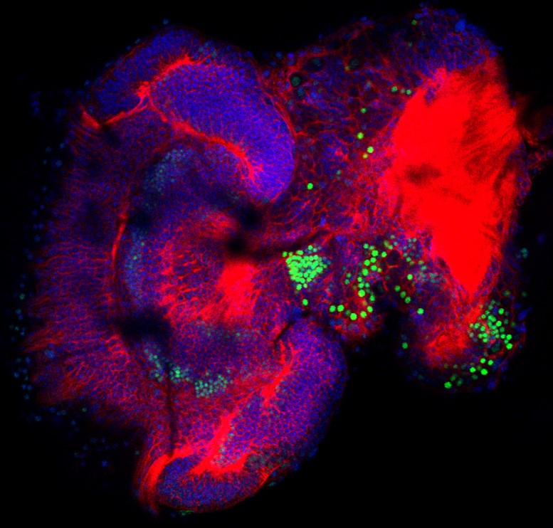

In the brain of bee larvae, FoxP is already strongly expressed in different neuron clusters (green), indicating the importance of the gene for development.

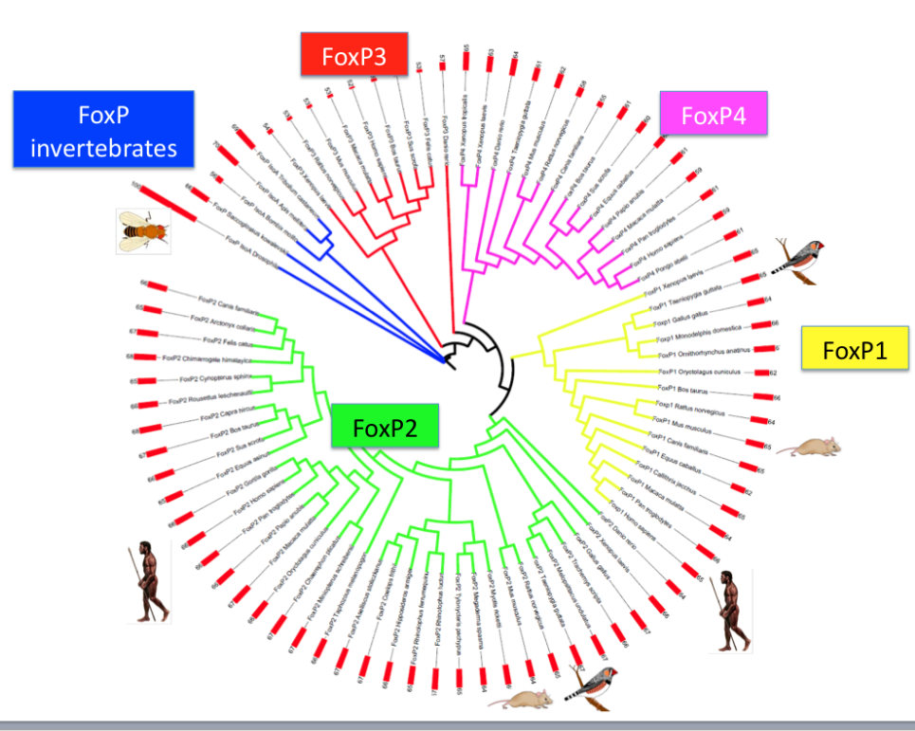

Text: Invertebrate FoxP gave rise through gene duplication to four different FoxP genes. In vertebrates. FoxP1, 2,and 4 are important for brain development and behavior and play a role in other organs too. FoxP3 functions in the immune system.

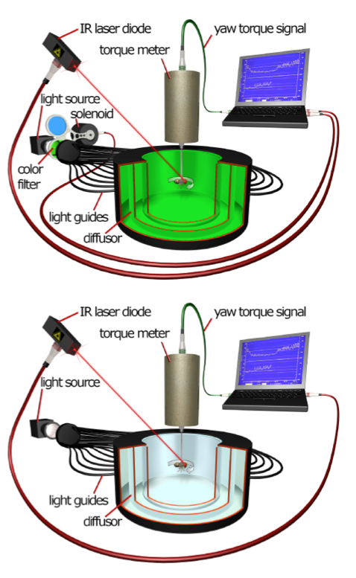

In experiments, fruit flies can be attached by a thin wire to a torque meter that monitors the direction in which they fly. Wild-type flies can be trained, using heat from a laser diode, not to fly into a particular direction. FoxP mutant flies are much worse at learning this task, but can learn to avoid a particular direction if the get additional visual information (green light) (from Mendoza et al., 2013)

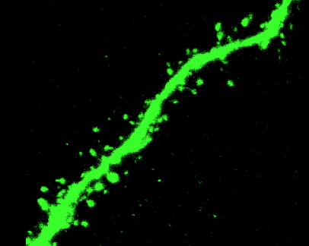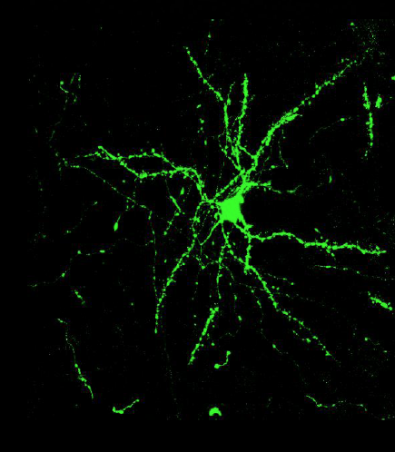

In songbirds and mammals, FoxP2 is expressed in so called medium spiny neurons of the striatum, a region important for translating sensory information into motor behavior. They neurons are called spiny because they have prominent ‚spines’ (right image), contact sites to receive signals from other neurons (photo: Jennifer Kosubek=

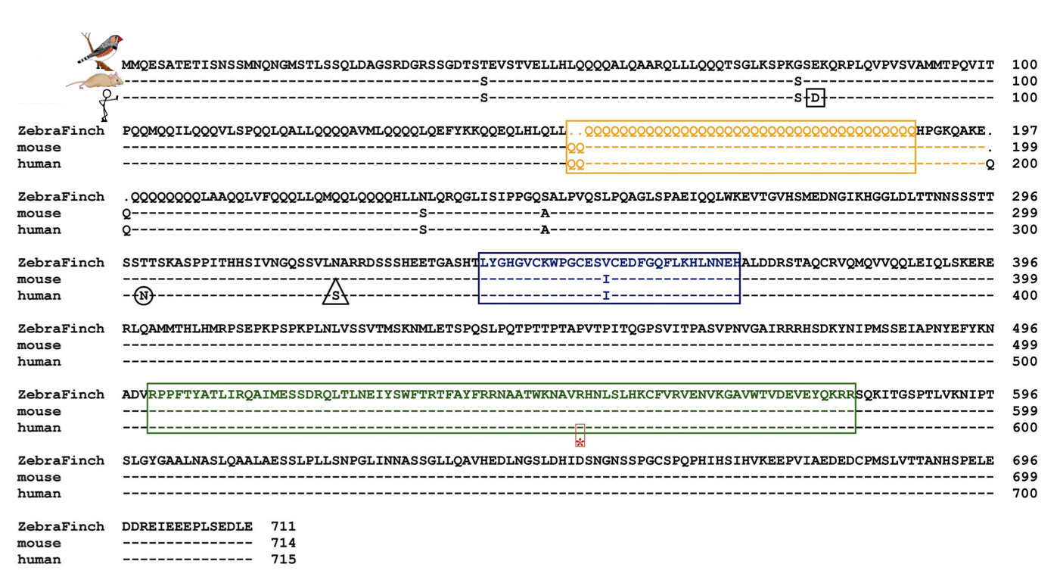

The amino acid sequence of FoxP2 in songbirds, mice and humans is almost identical (dashes). Humans and non-human primates differ in only two amino acids (circle and triangle). The DNA binding domain, the forkhead box (green) is identical in songbirds, mice and primates.

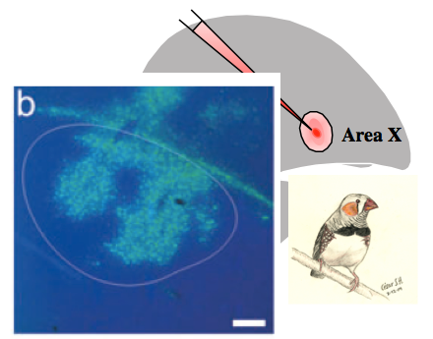

Targeting the song learning region Area X in juvenile male zebra finches with a virus (green in the inset) that leads to a reduction of FoxP2, impairs song learning.