THE CATHOLIC MONARCHS ON THE POSTAGE STAMPS OF FRANCO’S SPAIN.

ABSTRACT

Postage stamps are state products that certify postage payment for an item and, at the same time, a tool for promoting the objectives and the vision of the world of the state that issues them. The images on stamps are never neutral since their intentionality is evident from the moment a state, through various agencies or contractors, establishes and tries to maintain control of postage stamp production. For Franco’s regime, as for most governments worldwide, stamps were a symbol of sovereignty and carriers of historical and spiritual values because they were an expression of an autonomous national entity. Through its Plan Iconográfico Nacional (National Iconographic Scheme), Franco’s regime shaped the image of Spain as shown on postage stamps. The scheme established a series of preferences about what should be - and, therefore, what should not be - on postage stamps. This paper will review the representations on postage stamps of the Catholic Monarchs during Francoism. Due to their direct link with Spain’s imperial past, the Monarchs were essential and emblematic characters of Franco’s dictatorial regime, which used them as reminders to the Spanish people of the most glorious period of Spain’s history. This strategy was meant to provide historical references to legitimize the new state established by Franco in the eyes of public opinion.

KEYWORDS

Philately; Spain; Postage Stamps; Francoism; Catholic Monarchs

INTRODUCTION

This paper reviews postage stamps showing the portrait of the Catholic Monarchs, separate or together, issued during Franco’s dictatorship in Spain, not including the colonial territories. During the Spanish Civil War, the nationalist side postage stamps were produced by collaborating or confiscated companies and circulated in the conquered territories. The lack of materials due to a war economy and the lack of control in some aspects of the administration of a state at war makes it almost impossible to know how many stamps in each series were issued. This is why we will comment on the vignettes and some of the texts from the stamps chosen for this paper, but we will not emphasize the use of colors, perforations or print runs.

The Catholic Monarchs

The marriage formed by King Ferdinand II of Aragon (1479-1516) and Queen Isabella I of Castile (1474-1504) is known as the Catholic Monarchs, a title granted to it in 1492 by Pope Alexander VI (Rodrigo Borgia) for several reasons, among others, the successful conquest of Granada and the expulsion from Spain of the Jews. The title «was a recognition of power, not piety» (Tremlett, 2017, p. 373).
Isabella and Ferdinand each ruled in their own kingdom following the kingdom’s laws, although both could make decisions in their spouse's kingdom in the latter's absence. Also, they took power away from the nobles, concentrated it in their own hands. This fact, together with the expulsion of the Jews from their territories and the conquest and annexation of the Nasrid kingdom of Granada, the last Muslim dominion of the Iberian Peninsula, created the impression, particularly for certain later historians, that the unity of Spain under one sovereign took place at that time. However, Spain had only existed as a sovereign nation since the early 19th century, when the first constitution was promulgated in 1812.
For a long time, the reign of the Catholic Monarchs represented a specific idea of Spain: Catholic, governed by all-controlling rulers, politically and territorially united, expansionist and imperialistic. Furthermore, this was the idea of Spain that Francoism resorted to frame the ideals of the new state that emerged after the Spanish Civil War in 1939 and the defeat of the progressive ideals represented by the Second Spanish Republic.

The Second Spanish Republic

In April 1931, the Second Spanish Republic was proclaimed after municipal elections, in which the republican parties won by a majority. King Alfonso XIII was forced into exile. In December of that same year, a new Spanish constitution was adopted. Among
other advances, the secularity of the state, freedom of expression and assembly, women's suffrage, and divorce were legalized, and the privileges of nobility were annulled. New national symbols, such as a new flag and a new national anthem, were adopted. Although Spain was not a federal republic, Catalonia and the Basque Country became self-governed autonomous regions in 1932 and 1936. It was a time of attempts at social improvements, as well as social conflict. Strikes, revolutionary and secessionist attempts, clashes between right-wing and left-wing supporters, and political assassinations made the situation untenable. In response to such instability, a group within the military led by, among others, General Francisco Franco, initiated a coup d’état in July 1936, which was met with much resistance and led to civil war.

The Spanish Civil War

The Spanish Civil War took place in Spain between 1936 and 1939 between the left wing or republican and the right wing or nationalist sides. The democratically elected government, trade unions, communists, anarchists, and many workers and peasants formed the republic side. The nationalist side, led by General Franco, consisted of a rebellious part of the army, the bourgeoisie and the upper classes, the landowners, and the monarchists. Moreover, it had the explicit support of the Catholic Church, which defined the Spanish Civil War as a Crusade. For different reasons closely linked to the European context of the time, the republican side was supported by the Soviet Union and the European democracies. In contrast, the nationalist side had the support of the fascist governments of Germany and Italy.

Francoism

After their victory over the republican side, the nationalists established the dictatorship of General Franco, a regime whose ideological identity was defined as National Catholicism. Under Franco’s regime, the Catholic Church recovered former privileges stripped from it since the end of the 18th century. Throughout the Franco dictatorship, Spain suffered continuous international isolation, which weakened as the years passed. As the Spanish dictator wanted his country to be recognized internationally, and after that happened, a certain kind of improvement in social life gradually began. In the 1950s, Spain was accepted as a member of the United Nations, and in 1969, Franco appointed Prince Juan Carlos, the grandson of Alfonso XIII, as his successor in office.
Like any other regime, dictatorial or democratic, Francoism used any means to disseminate propaganda messages, especially the mass media, to its citizens and those overseas, and postage stamps were no exception.

Postage stamps as conveyors of messages

Postage stamps are graphic products conceived, designed, produced, and sold by the state. As such, they are controlled, throughout the process, by the political power governing the country that issues them, if the postal services are publicly run. Many states conform the production and imagery of postage stamps to their interests, which are mainly economic, namely the payment for services rendered requiring the development of a postal network for the issuing country. However, postage stamps are also conditioned by other factors, which are ideological, that is, based on a particular set of ideas or beliefs. Most states use postage stamps to convey ideological messages (Navarro Oltra, 2009; Navarro Oltra y Senís Fernández, 2016); even if the images appearing on postage stamps, such as industrial products, may seem banal, showing such products on stamps conveys the message of the country's economic potential, a form of propaganda. Therefore, the ideology of a state, whatever it is, can be guessed through its postage stamp production.
Messages conveyed on postage stamps have an essential ideological component as they express what the state, according to its own criteria wants to show of itself to the world. These messages tend to have a politically proselytizing aspect, disguised behind a veneer of -mainly- civic values. The range of topics shown on stamps is rooted in their suitability to improve the country’s image. Therefore, stamps only commemorated events that the government believed offered a positive vision of the regime or would help construct a national identity.
This statement would not be possible without considering the work of key authors who have facilitated the study of postage stamps and the messages they convey. And the fact is that when Carlos Stoetzer published Postage Stamps as Propaganda in 1953 (Stoetzer, 1953), he laid the foundations for studying the postage stamp as a tool to disseminate ideology and propaganda. His work established the guidelines for postage stamp analysis to be used by many studies published after that. In 1975 Harlan J. Strauss published «Politics, Psychology and the Postage Stamp» which studied messages conveyed on stamps from the psychological point of view (Strauss, 1975). Donald M. Reid considered stamps as historical documents in his 1984 paper «The Symbolism of Postage Stamps: A Source for the Historian» (Reid, 1984). In 1995 David Scott established the three functions of the postage stamp as a sign: indicative, representative, and commemorative in his book, European Stamp Design. A Semiotic Approach To Designing Messages (Scott, 1995). Later he would concur with Alexis Schwarzenbach in defining postage stamps as places of remembrance in their respective works, «The semiotics of the lieu de mémoire: The postage stamp as a site of cultural memory» (Scott, 2002) and Portraits of the Nation: Stamps, Coins, and Banknotes in Belgium and Switzerland, 1880-1945 (Schwarzenbach, 1999). Stanley D. Brunn highlighted postage stamps as tools for reinforcing national identity in existing and newly created countries in his paper «Stamps as iconography: Celebrating the independence of new European and Central Asian states» (Brunn, 2000). Since then, many authors, who look at postage stamps as carriers of messages, study stamps from the most diverse perspectives but almost always within a specific geopolitical context (Brennan, 2018; Brunn, 2018, 2022; Navarro Oltra y Medina, 2018; Limor y Tamir, 2020; Moriente y Navarro, 2022).
In the present case, we will focus on the postage stamp as an instrument that Franco used to reinforce domestically a series of ideas and concepts through symbols and symbolic characters, in this case, the Catholic Monarchs. The discussion of the stamps will be chronological; unless otherwise indicated, the stamps of a series have the same illustration; only colors and face values change. First, we will review the role of the postage stamp in Franco’s regime and then comment on the Plan Iconográfico Nacional (National Iconographic Scheme, from now on NIS) and how it shaped Spanish postal issues. Finally, we will analyze the postage stamps (and a stamped card) in which the Catholic Monarchs appear, together or separately, and study the sources of the images and the legislation establishing their issuance. In this way, we will show the importance of the Catholic Monarchs in the ideology of Franco´s regime and its philatelic program.

THE POSTAGE STAMP IN FRANCO’S SPAIN

States have used postage stamps as an educational tool and have used them to show their version of history to their citizens and to tell this same audience with what they should identify and of what they should be proud (Brennan, 2018). In Franco’s Spain, since the beginning of the Spanish Civil War, a process of regression began concerning civic values in contrast to those of the Second Spanish Republic, which were mainly progressive. As part of the process of implanting regressive values, the nationalist side issued postage stamps commemorating characters with a close historical association to its version of the history of Spain, based on Catholicism, territorial unity, imperial expansionism, and undisputed power.
This trend began before the nationalists had even won the war, when they were still the insurgents, and released their first postage stamps showing Queen Isabella in January 1937 (Boletín Oficial del Estado, 1937b, 1937c). As Stoetzer pointed out, writing about Spain, the nationalist side used postage stamps images favorable to their aims, such as the portraits of the Catholic Monarchs, symbols of the unification of the territory, and allegorical representations of a glorious past. Sometimes, overprinted text, such as «Saludo a Franco» and «Arriba España» (Up with Spain), reinforced the messages of these vignettes (Stoetzer, 1953, pp. 16-17).
During Franco’s dictatorship, images mainly from the art world were used to represent topics on postage stamps, especially in the case of portraits of historical figures. Using works of art, monuments, and buildings to illustrate the most diverse topics showed Spain’s specific and diverse historical and cultural background. The main objectives in the selection of artworks for use on postage stamps were to reinforce the ideas of the greatness of Spain’s past, the importance of its traditions, the inherent and ancestral Catholicism of its people, its importance and relevance in both the ancient and contemporary world, and the suitability of the political system that governed it.
Using an existing painting or photograph on a postage stamp was one of the ways of commemorating individuals from the early years of Franco’s regime, especially when combined with another image in the background. That is, using a portrait of the commemorated figure with another pre-existing image (also from the art world) in the background that represents one of the events in which the figure has been the protagonist. This way of proceeding when composing a vignette established a visual link between the figures commemorated and their actions. Many of these compositions had text added to serve as labeling, facilitating the understanding of what stamps showed.

THE NATIONAL ICONOGRAPHIC SCHEME

In 1941, Franco’s dictatorial government agreed to create an agency dependent on the state, the Oficina Filatélica del Estado (State Philatelic Office). The regulations of this Office, approved in 1943 by the Council of Ministers, established that its primary function would be to improve Spanish philatelic production, namely, to stimulate the postage stamp’s potential as a source of income for the state and to make postage a viable tool for improving Spain’s image abroad, but, no mention was made of improving the Spaniards’ appreciation of the regime (Boletín Oficial del Estado, 1943). However, this type of comment was not usual in other governmental documents. Within a few months of the State Philatelic Office becoming operational and upon its proposal, in July 1944, the government established the National Iconographic Scheme (NIS) (Boletín Oficial del Estado, 1944). The NIS specified how subjects commemorated on postage stamps should be chosen and represented, something never regulated by law since the 1850 introduction of Spanish postage stamps. Designed to present a specific image of Spain at home and overseas, the NIS guidelines fixed the topics and the type of images to represent the country on stamps (Boletín Oficial del Estado, 1944).
On most postage stamps, historical figures are commemorated through their portrait. According to the NIS, when possible, an authentic portrait should be chosen which meant that preference was given to portraits painted from life. In the absence of such a portrait, representations of individuals that demonstrated their personalities/leading characteristics and taken from important art works or the works of important artists should be considered (Boletín Oficial del Estado, 1944, p. 5304). In addition, in many stamps, the portrait was accompanied by a short text or a reference to a legend, which helped the viewer understand whom or what was shown on the stamp.

THE CATHOLIC MONARCHS ON THE FRANCOISM POSTAGE STAMPS

For Franco’s regime, the reign of the Catholic Monarchs (1474-1516) symbolized the territorial, political, and religious unity of Spain. It was the primary historical reference for his authoritarian, Catholic, and imperialist discourse (Ortiz Pradas, 2017). Francoism adapted the emblems used by the Catholic Monarchs to identify with a new era of national unity, economic prosperity, and imperial glories.

First series: Queen Isabella the Catholic

From January 1937 to August 1939, the nationalist side issued a definitive series of 18 denominations that covered all types of mail to be used in the correspondence sent from the territories it controlled. In this series, Queen Isabella the Catholic appeared for the first time in Spanish philately, and it did so in 10 of 18 denominations (Figure 1) (Boletín Oficial del Estado, 1937b). For the vignette, or the central image on the stamp, the portrait made by Juan de Flandes (c. 1500-1504), now located in the Palacio Real, was used as visual reference. On the stamp, apart from the texts indicating the function Correos (Postage), origin España (Spain), and face value, there is the text «Isabel la Católica».

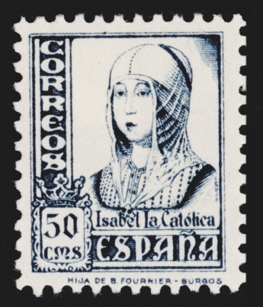 | Figure 1. 50 cms Postage Stamp with a portrait of Isabel the Catholic. Spain (1937)  Scott Nº. 650  Image from the Museo Casa de la Moneda, Madrid (Spain). Photographed with permission of the Fábrica Nacional de Moneda y Timbre-Real Casa de la Moneda (FNMT-RCM), Madrid (Spain).

Stamped card: The Catholic Monarchs

In November 1937, the nationalist side issued a stamped card (Figures 2 and 3), destined for domestic mail, in which the stamp printed on it depicts a portrait of the Catholic Monarchs (Boletín Oficial del Estado, 1937a). That portrait was inspired by coins minted in Segovia during the Catholic Monarchs’ reign, as shown by the small «aqueduct» of the Segovia Mint mark on the top. Ferdinand and Isabella looked at each other in these coins, reinforcing the idea of their equality and equivalence (Figure 4) as established by the Concord of Segovia of 1475. The Concord established that «Ferdinand’s name would go first on their joint documents and coins, but her shield had precedence» (Tremlett, 2017, p. 105). This relationship between equals is reflected in their motto, «Tanto Monta» (Tantamount), underneath their portraits. The cross between them reinforces the idea of Catholicism, not only of the kings but also of the forces issuing the card.

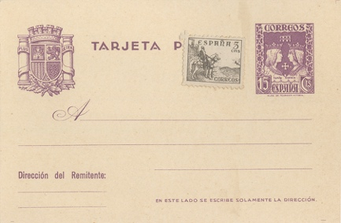 | Figure 2. Stamped Card (back) with a portrait of the Catholic Monarchs. Spain (1937)  Edifil Nº. 81  From the collection of the author
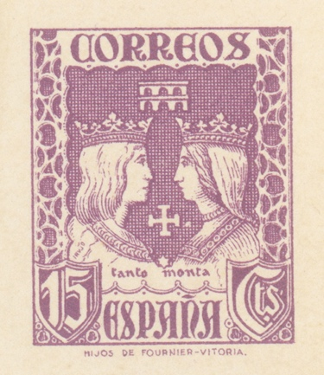 | Figure 3. Stamped Card (back detail) with a portrait of the Catholic Monarchs. Spain (1937)  Edifil Nº. 81  From the collection of the author
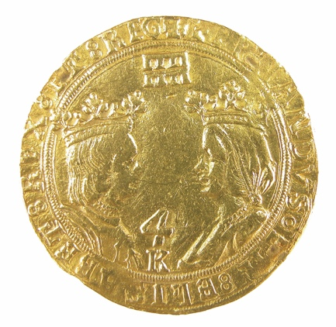 | Figure 4. 4 Excelentes with a portrait of the Catholic Monarchs. Segovia (Spain) (c. 1515)  Gold  Image from the Museo Casa de la Moneda, Madrid (Spain). Photographed with permission of the Fábrica Nacional de Moneda y Timbre-Real Casa de la Moneda (FNMT-RCM), Madrid (Spain).

Second series: King Ferdinand the Catholic

In January 1938, the nationalist side began to issue the first definitive postal series of four denominations featuring King Ferdinand the Catholic (Figure 5) (Boletín Oficial del Estado, 1938), adding several two more denominations to the series in the following months. This series has some stylistic similarities with the abovementioned Queen Isabella series. The portrait that inspired the one on the stamps is a copy by an anonymous artist of a lost original (Pardo Canalís, 1963), now located at the Museum of the Royal Chapel of Granada (Spain). The label «Fernando el Católico» appears on this stamp, in addition to the function, origin, and face value indicators.

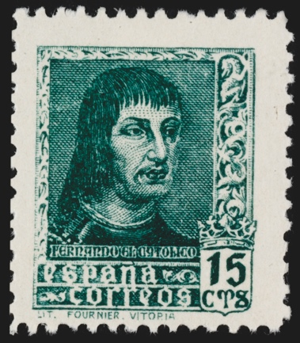 | Figure 5. Postage Stamp with a portrait of Ferdinand the Catholic. Spain (1938)  Scott Nº. 656  Image from the Museo Casa de la Moneda, Madrid (Spain). Photographed with permission of the Fábrica Nacional de Moneda y Timbre-Real Casa de la Moneda (FNMT-RCM), Madrid (Spain).

Third series: Queen Isabella the Catholic

From August 1938 until June 1939 (Edifil, 2021), a new definitive series of six denominations featuring Isabella the Catholic (Figure 6) was issued based on the same portrait by Juan de Flandes mentioned before. This series has many graphic similarities with the previous one. Both have in common a portrait with a dark background and labeling in widely recognizable medieval-looking typefaces. These typefaces reinforced the Francoist historiography idea that Spain had an origin that was centuries old.
At the end of the Spanish Civil War in April 1939, Franco became head of state, and until he died in 1975, he was the only subject to appear in the vignettes of the Spanish definitive postage stamps.

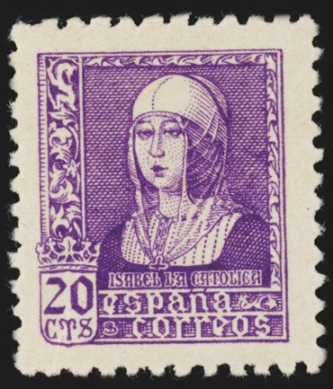 | Figure 6. Postage Stamp with a portrait of Isabel the Catholic. Spain (1938)  Scott Nº. 672  Image from the Museo Casa de la Moneda, Madrid (Spain). Photographed with permission of the Fábrica Nacional de Moneda y Timbre-Real Casa de la Moneda (FNMT-RCM), Madrid (Spain).

Fourth series: the fifth centenary of the birth of Isabella the Catholic

In 1951, two commemorative series of five denominations each were issued to commemorate the fifth centenary of the birth of Isabella the Catholic. The Boletin Oficial del Estado (Spanish Official Gazette) noted that the series fulfilled «the undeniable duty of remembrance, exaltation, and homage to the illustrious figure without equal in our History» (Boletín Oficial del Estado, 1950).
The first of these postal series was destined for domestic mail. It shows Isabella the Catholic without indicating who she is (Figure 7). However, the portrait is analogous to the one used in the 1937 and 1938 series and to that used previously on banknotes, postage stamps, schoolbooks, etc. Nevertheless, photogravure being the printing technique, the appearance is more like the original painting that served as a model than these earlier examples.

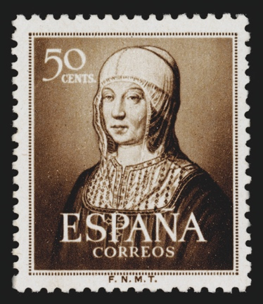 | Figure 7. Postage Stamp with a portrait of Isabel the Catholic. Spain (1951)  Scott Nº. 781  Image from the Museo Casa de la Moneda, Madrid (Spain). Photographed with permission of the Fábrica Nacional de Moneda y Timbre-Real Casa de la Moneda (FNMT-RCM), Madrid (Spain).

Fifth series: the fifth centenary of the birth of Isabella the Catholic

On the other hand, the next series, destined for international air mail (Figure 8), shows on the foreground a portrait painted by Juan Antonio Morales. This portrait offers an image of Queen Isabella that is very different from the one used until then. This painting was commissioned in 1949 by the Minister of Foreign Affairs, Alberto Martín Artajo, who wanted to create a more attractive image of the Queen (Arias Serrano, 2005). Morales also painted a portrait of King Ferdinand that would appear in a 1952 commemorative air mail series. This change of image and its consolidation in popular culture culminated in 1957. That year the Bank of Spain issued a 1000 peseta banknote, the largest denomination at the time (Figure 19). Its obverse side bore a portrait of the Catholic Monarchs together, from another painting by Morales. The inspiration for Morales’ portrait of Isabella the Catholic came from another painting, Holy Family with St. Magdalene and St. Catherine, also known as The Virgin of the Fly (c. 1520) by an anonymous Flemish artist, which is in the Collegiate Church of Toro (Zamora, Spain).
Apart from the new portrait, this air mail postage stamps commemorative series presents several differences from the previous one despite commemorating the same anniversary. These differences lie in the function, printing technique (intaglio), format, and the inclusion of a caption. The vignette also contains in the background an evocative image alluding to the figure commemorated. The image used for the background was The Surrender of Granada by Francisco Pradilla Ortiz and commissioned by the Spanish Senate in 1882 (Díez et al., 1992). This painting shows the last Muslim king of Granada, Boabdil, handing over the city’s keys to the Catholic Monarchs as confirmation of the city’s surrender in January 1492. Francoism saw the annexation of Granada to Castile and Aragon as a turning point in the history of Spain; because, according to the Franco regime’s revision of history, Ferdinand and Isabella had united Spain geopolitical and religiously after the expulsion of the Jews that same year.

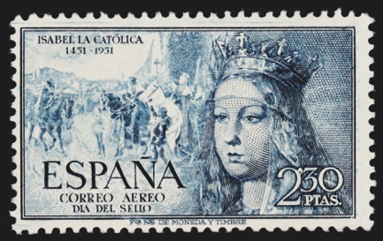 | Figure 8. Air Mail Postage Stamp with a portrait of Isabel the Catholic. Spain (1951)  Scott Nº. C136  Image from the Museo Casa de la Moneda, Madrid (Spain). Photographed with permission of the Fábrica Nacional de Moneda y Timbre-Real Casa de la Moneda (FNMT-RCM), Madrid (Spain).
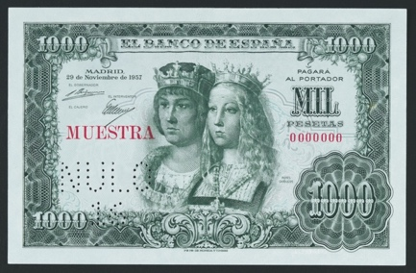 | Figure 9. Banknote with a portrait of the Catholic Monarchs. Spain (1957)  Image from the Museo Casa de la Moneda, Madrid (Spain). Photographed with permission of the Fábrica Nacional de Moneda y Timbre-Real Casa de la Moneda (FNMT-RCM), Madrid (Spain).

Sixth series: the fifth centenary of the birth of Ferdinand the Catholic

In 1952 two postal series of five denominations each were issued commemorating the fifth centenary of the birth of King Ferdinand the Catholic (Figure 10). The visual appearance of the two series, one for domestic mail and one for international air mail, is identical to the series commemorating the fifth centenary of the birth of Isabella the Catholic. The portrait used to represent King Ferdinand, unlike that of Queen Isabella the Catholic, is not the same as the one used in the 1938 definitive series. This time it was a portrait of Ferdinand II of Aragon painted by an anonymous English artist which hangs in Windsor Castle. It seems that the portrait was chosen from the same period as the one used in the stamps showing Isabella the Catholic at the beginning of the 16th century to obtain more visual coherence between both postal series.

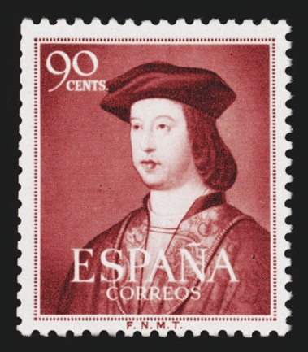 | Figure 10. Sello postal with a portrait of Ferdinand the Catholic. Spain (1952)  Scott Nº. 789  Image from the Museo Casa de la Moneda, Madrid (Spain). Photographed with permission of the Fábrica Nacional de Moneda y Timbre-Real Casa de la Moneda (FNMT-RCM), Madrid (Spain).

Seventh series: the fifth centenary of the birth of Ferdinand the Catholic

The commemorative air mail postal series follows the same pattern as the Queen Isabella series of the previous year. In the foreground is the interpretation of the portrait of the monarch made in 1949 by Juan Antonio Morales (Figure 11). In the background is a scene that, contrary to the assertions of other writers, does not reproduce Ricardo Balaca’s canvas Christopher Columbus before the Kings of Spain on his return from his first voyage (1874) (Aranaz Río y Alemany Indarte, 2000, p. 296). It seems likely that the model used was the U. S. 1893 commemorative stamp 10-cent Columbus Presenting Natives from the Columbian Exposition series due to the similarities between the vignettes in both stamps. The stamp represents Luigi Gregori’s Return of Columbus and Reception at Court (1882-1884) (Haimann n. d.). This series was the topic of a 1992 joint commemorative issue between the United States, Spain, Italy, and Portugal (Figure 12).

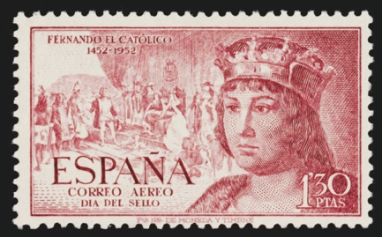 | Figure 11. Air Mail Postage Stamp with a portrait of Ferdinand the Catholic. Spain (1952)  Scott Nº. C141  Image from the Museo Casa de la Moneda, Madrid (Spain). Photographed with permission of the Fábrica Nacional de Moneda y Timbre-Real Casa de la Moneda (FNMT-RCM), Madrid (Spain).
Figure 12. Postage Stamp representing Luigi Gregori’s Return of Columbus and Reception at Court USA (1992)
Scott Nº. 2628a
From the collection of the author

CONCLUSIONS

During the Spanish Civil War and after defeating the legitimate government of the Second Spanish Republic, Francoism needed models and references to justify and shape itself. For this, generating a whole new system of symbols was necessary to represent the newly established order. Some of these symbols were adaptations of others from the reign of the Catholic Monarchs. Franco’s regime chose symbols from that era as referents because the Catholic Monarchs were of great importance in the configuration of modern Spain. Their reign represented for Francoism a time to emulate, a time of Catholicism, undisputed rulers, territorial unity, and imperial expansion.
Franco’s regime resorted to any media that could use to configure the slogans and messages it wanted to communicate. Mass media were the most obvious choice, and the stamps were no exception. Postage stamps were used among coins, banknotes, comics, etc. in this propaganda campaign to subtly legitimize the regime and indoctrinate the population as part of a process known as «subliminal ideologization» (Ascunce Arrieta, 2008, pp. 180-181). For example, the Catholic Monarchs appeared in schoolbooks, stamps, medals, posters, and even cigarette boxes.
Although some other historical figures were commemorated philatelically, King Ferdinand and Queen Isabella remain, besides Franco, the most commemorated figures on postage stamps during Franco’s regime, not only for the number of postal series but also for the number of denominations and stamps printed.
The Francoist state was aware of the potential of the postage stamp as a means by which ideology and propaganda messages could circulate; this potential lasted in time, even after the stamp served its postal purpose, that is, through collecting. Due to the widespread diffusion and long-lasting life of postage stamps, Franco’s government used them to disseminate all the ideology and symbols of the regime, including the Catholic Monarchs as referents of an indivisible and Catholic Spain, for its assimilation by the population in an enjoyable way: through beautiful images. By acting this way, Francoism used all the resources in graphic production to show itself at its best. It represented itself by showing its ideals and what it wanted Spain to be.

BIBLIOGRAPHY

- Aranaz Río, F. y Alemany Indarte, L. (2000) 150 años de sellos, correos y filatelia. De Isabel II a Juan Carlos I. (1850-2000). 1.ª ed. Madrid: Correos y Telégrafos.
- Arias Serrano, L. (2005) El pintor Juan Antonio Morales. De la vanguardia al retrato de sociedad. 1.ª ed. Valladolid: Diputación de Valladolid.
- Ascunce Arrieta, J. A. (2008) «Recursos de ideologización en la primera prensa del franquismo. Vértice como ejemplo», en Mendelson, J. (ed.) Revistas, Modernidad y Guerra. 1.ª ed. Madrid: Museo Nacional Centro de Arte Reina Sofía, pp. 165-183.
- Boletín Oficial del Estado (1937a) Orden.- Autorizando la circulación de las tarjetas postales cuyas características se reseñan, para el servicio de Correos en el interior de la Nación. Available online: https://www.boe.es/datos/pdfs/BOE//1937/326/A03299-03299.pdf.
- Boletín Oficial del Estado (1937b) Orden.- Disponiendo la puesta en circulación de dos clases de sellos para el franqueo de correspondencia, de cinco y treinta céntimos de peseta. Available online: https://www.boe.es/datos/pdfs/BOE//1937/077/A00035-00035.pdf.
- Boletín Oficial del Estado (1937c) Orden.- Disponiendo que, transcurrido el plazo de diez días, a contar de la publicación de esta Orden, no se admitirán para el franqueo de la correspondencia otros timbres que los correspondientes a las emisiones que se detallan. Available online: https://www.boe.es/datos/pdfs/BOE//1937/275/A02483-02483.pdf.
- Boletín Oficial del Estado (1938) Orden disponiendo la puesta en circulación de un sello de treinta céntimos de franqueo de correspondencia de las características que se citan. Available online: https://www.boe.es/datos/pdfs/BOE//1938/455/A05323-05323.pdf.
- Boletín Oficial del Estado (1943) Orden de 27 de enero de 1943 por la que se aprueba el reglamento de la Oficina Filatélica del Estado. Available online: https://www.boe.es/datos/pdfs/BOE//1943/032/A01093-01096.pdf.
- Boletín Oficial del Estado (1944) Orden de 5 de julio de 1944 por la que se fija el plan iconográfico en la elaboración de sellos de correos. Available online: https://www.boe.es/datos/pdfs/BOE//1944/191/A05303-05304.pdf.
- Boletín Oficial del Estado (1950) Orden de 23 de junio de 1950 sobre emisión de sellos conmemorativos del V Centenario del nacimiento de Isabel la Católica. Available online: https://www.boe.es/datos/pdfs/BOE//1950/190/A02989-02990.pdf.
- Brennan, S. A. (2018) Stamping American Memory. Collector, Citizens and the Post. First. Ann Arbor, MI: University of Michigan Press. doi: 10.3998/mpub.9847183.
- Brunn, S. D. (2000) «Stamps as iconography: Celebrating the independence of new European and Central Asian states», GeoJournal, 52(4), pp. 315-323. doi: 10.1023/A:1014307914500.
- Brunn, S. D. (2018) «The state branding of US postage stamps for state commemorative years: from heritage, iconography and place to placelessness», en Ermann, U. y Hermanik, K.-J. (eds.) Branding the Nation, the Place, the Product. First. New York City: Routledge, p. 176. Available online: https://www.loc.gov/resource/g3850.ct000091/.
- Brunn, S. D. (2022) «An Emerging World of LGBT Stamps BT - Mapping LGBTQ Spaces and Places: A Changing World», en Blidon, M. y Brunn, S. D. (eds.). Cham: Springer International Publishing, pp. 677-694. doi: 10.1007/978-3-031-03792-4_40.
- Díez, J. L. et al. (1992) La Pintura de historia del siglo XIX en España. Madrid: Museo del Prado.
- Edifil (2021) Catálogo unificado especializado de sellos de España 2021. Tomo III. Estado Español. 1936-1975. 28.ª ed. Madrid: EDIFIL.
- Haimann, A. T. (sin fecha) 10-Cent Columbus Presenting Natives, Columbian Exposition Issues (1893). Available online: https://postalmuseum.si.edu/exhibition/about-us-stamps-classic-period-1847-1893-american-bank-note-company-1879-1893/columbian
- Limor, Y. y Tamir, I. (2020) «The Neglected Medium: Postage Stamps as Mass Media», Communication Theory. doi: 10.1093/ct/qtz043.
- Moriente, D. y Navarro, G. (2022) «La invención de Guinea Ecuatorial en la España de Franco: una visión de la colonia a través de los sellos de correos», Bulletin of Spanish Visual Studies. Routledge, pp. 1-21. doi: 10.1080/24741604.2022.2090796.
- Navarro Oltra, G. (2009) Autorretratos del Estado. Una aproximación al sello postal del franquismo como medio de emisión de mensajes ideológicos (1936-1975). Universidad de Castilla-La Mancha. Available online: http://hdl.handle.net/10578/1440.
- Navarro Oltra, G. y Medina, F. X. (2018) «Sellos, turismo y gastronomía: El papel de la gastronomía en la promoción turística de España a través de los sellos de correos», PASOS Revista de Turismo y Patrimonio Cultural, 16(4). doi: 10.25145/j.pasos.2018.16.065.
- Navarro Oltra, G. y Senís Fernández, J. (2016) El sello postal en España. Autorretratos del Estado. 1.ª ed. Madrid: Correos/FNMT-RCM.
- Ortiz Pradas, D. (2017) «“Tanto monta”. Apropiación de los símbolos e imagen de los Reyes Católicos durante el franquismo», en El franquismo y la apropiación del pasado: el uso de la historia, de la arqueología y de la historia del arte para la legitimación de la dictadura. 1.ª ed, pp. 253-269.
- Pardo Canalís, E. (1963) Iconografía de Fernando el Católico. 1.ª ed. Zaragoza: Institución «Fernando el Católico» (C. S. I.C.) Zaragoza.
- Reid, D. M. (1984) «The Symbolism of Postage Stamps: A Source for the Historian», Journal of Contemporary History. Sage Publications, Ltd., 19(2), pp. 223-249. Available online: http://www.jstor.org/stable/260594.
- Schwarzenbach, A. (1999) Portraits of the Nation: Stamps, Coins, and Banknotes in Belgium and Switzerland, 1880-1945. Peter Lang (European University Studies. Series XX, Philosophy).
- Scott, D. (1995) European Stamp Design. A Semiotic Approach To Designing Messages. 1.ª ed. London: Academy Editions.
- Scott, D. (2002) «The semiotics of the lieu de mémoire: The postage stamp as a site of cultural memory», Semiotica. Walter de Gruyter GmbH & Co. KG, 2002(142), pp. 107-124. doi: 10.1515/semi.2002.069.
- Stoetzer, C. (1953) Postage Stamps as Propaganda. Washington, D.C.: Public Affairs Press.
- Strauss, H. J. (1975) «Politics, Psychology and the Postage Stamp», en The Congress Book 1975: Forty-First American Philatelic Congress. Federalsburg: The American Philatelic Congress, pp. 157-180.
- Tremlett, G. (2017) Isabella of Castile: Europe’s First Great Queen. 1.ª ed. London: Bloomsbury Publishing.

Stamp numbers are taken from the 2020 Standard Postage Stamp Catalogue, Volumes I (USa & A-B) and VI (S-Z), courtesy of Scott Publishing. Scott Publishing Company, Scott Standard Postage Stamp Catalogue (Sidney, Ohio: Amos Media Co., 2019). The marks SCOTT and SCOTT’S are Registered in the U.S. Patent and Trademark Office, and are trademarks of Amos Press, Inc., dba Scott Publishing Company. No use may be made of these marks or of material in this publication that is reprinted from a copyrighted publication of Amos Press, Inc., without the express written permission of Amos Media Co., Sidney, Ohio 45373. (Scott Publishing Company 2019)
The stamped card number corresponds to the numbering of the Edifil Catalogue (Edifil 2021)

